Ultimate Guide to the MECE Framework
Meta description: WSG founder Stephen Turban explains the MECE framework from his McKinsey days: four ways to cut a problem, worked issue trees with the math, and ten drills.

A few months into my first year at McKinsey, I drew an issue tree, my best attempt at the MECE framework we'd all been taught, on the team room whiteboard before anyone else arrived. Six branches, each one a reason the cost line we were studying could have grown. My engagement manager (the person who runs the day-to-day work on a project) walked in, looked at it for about ten seconds, picked up a marker, and drew a line through branch four. Then an arrow from branch four into branch two. Everything in the fourth branch, she said, was already a kind of the second. Then she asked what we'd do if the cause was something none of the six covered. I didn't have an answer. We redrew it together with three branches, and those three held for the rest of the project.

That marker line is the whole MECE framework. Mutually exclusive: no branch overlaps another. Collectively exhaustive: the branches together cover every possibility. I'm Stephen Turban. I went to Harvard, spent two years at McKinsey, and now run WallStreetGuide, where I prep undergrads for consulting interviews. MECE is the one idea I end up re-teaching in almost every mock case, because everyone knows the acronym and almost nobody can run the test.

This guide is the version of that whiteboard session I'd give a sophomore: what MECE means in plain words, where it came from, the four ways to cut any problem, four fully worked issue trees with the arithmetic shown, the ways a tree goes wrong, and ten drills with answers.

What does MECE mean?
MECE stands for mutually exclusive, collectively exhaustive, and it describes a list where every item fits exactly one bucket and the buckets together cover everything. Mutually exclusive means no overlap, and collectively exhaustive means no gaps. Consultants use it to break a vague question into pieces they can work one at a time, so no cost, customer, or cause gets counted twice and none gets missed. Most people say "mee-see"; the woman who coined it says it rhymes with "niece," and I'll get to that fight below.

Why do consulting interviewers care about MECE?
Interviewers care about MECE because a MECE structure is the only kind they can follow, test, and trust in the 25 minutes a case gives them. If two of your branches overlap, the interviewer can't tell which one you're investigating when you ask for data, and if they leave a gap, the real answer can sit where you'll never look and the case stalls. The opening structure is also graded on its own at McKinsey, BCG, and Bain, before any math happens, which is why what a case interview is really comes down to whether you can build and defend one. A clear three-branch tree with no overlap beats a brilliant list of nine ideas every time, because the interviewer can see where you're going.

1. The MECE framework in plain words: start with a room, not a business
Forget business for a minute. Say you run a town festival and you want to know who came. You hand a volunteer four boxes and 1,000 ticket stubs, each with the holder's age on it, and ask her to sort: under 18, 18 to 30, 30 to 50, and 50 and over. Looks fine. Then a 30-year-old's stub turns up and she has to pick between box two and box three. Same for every 50-year-old. Two of the boxes overlap, so the count you get back depends on which way she leaned each time.

Now fix it the lazy way: under 18, 20 to 29, 30 to 49, 50 and over. No overlap. But where does an 18-year-old go? A 19-year-old? Nowhere. Those stubs end up in a pile on the floor and your count runs short.

The version that works is under 18, 18 to 29, 30 to 49, 50 and over. Every person has exactly one age, every age lands in exactly one box, and the four boxes hold everyone from a newborn to a hundred-year-old. No stub fits two boxes (mutually exclusive). No stub fits none (collectively exhaustive). MECE is the rule that every item goes in exactly one box and the boxes together hold everything.

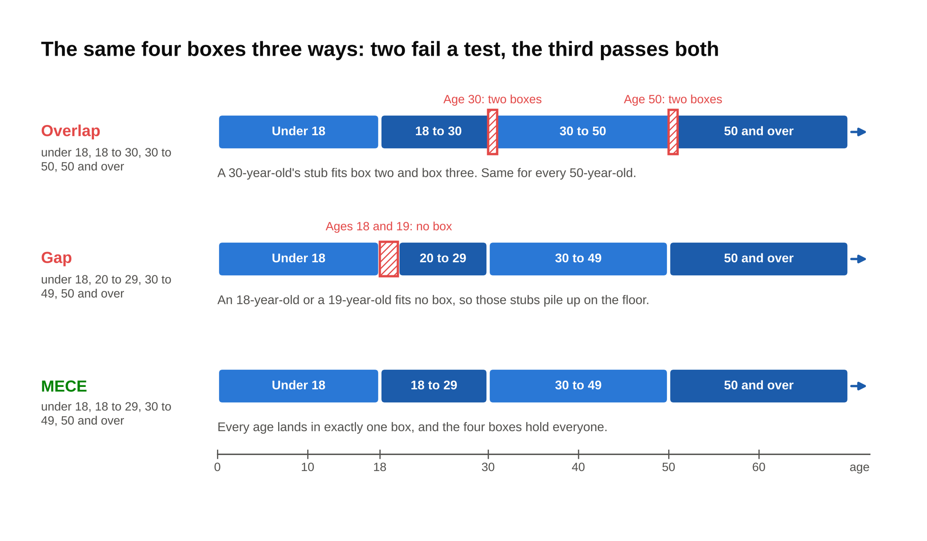
Sort the same 1,000 ticket stubs three ways and the test is visible: the first set claims 30-year-olds twice, the second has no box for an 18-year-old, and only the third passes both.

The trap that catches smart people is sorting by more than one thing at once. "Students, parents, seniors" sounds like a reasonable set of boxes for the festival. It fails both tests. A 70-year-old who brought her grandkids is a parent and a senior. A 35-year-old with no kids and no classes is none of the three. The three boxes came from three different questions (do you study, do you have kids, how old are you) stacked into one row.

Business is the same festival with a dollar sign. Take the prompt "a city's bus ridership fell 10 percent this year, why?" Total rides are the number of riders times the trips each rider takes. A drop has to come from fewer riders, fewer trips per rider, or both, and those two boxes can't overlap because one counts people and the other counts behavior. Under "fewer riders" you can sort again: people who moved away, people who switched to a car or a bike, people who stopped commuting because they work from home. Under "fewer trips per rider" you sort by the reasons someone who still rides would ride less: a route cut, a fare increase, a schedule change. Two levels down, you still have boxes that don't overlap and don't leave anyone on the floor, and you can keep going. An issue tree is just a stack of MECE sorts, each level splitting one box from the level above.

2. Where the MECE framework came from: Barbara Minto and a McKinsey writing problem
The word has an inventor, and the story explains why it stuck. Barbara Minto coined MECE at McKinsey in the 1960s while fixing how consultants wrote, not how they solved problems. She finished Harvard Business School in 1963, one of only a handful of women in a class of about 600 [VERIFY: Wikipedia says eight women; HBS only began admitting women directly to the two-year MBA in 1963, so check how her class is counted]. McKinsey hired her that same year, in its Cleveland office, as the first woman with an MBA on its consulting staff. In 1966 the firm moved her to London, and her job turned into fixing the writing. Reports she saw in the Paris and Düsseldorf offices had the same problem she'd seen in the US and the UK: findings and conclusions jumbled together, hard to follow. Her diagnosis, in her words to McKinsey's alumni site: "The problem was the thinking, not the language."

Every report she rewrote, she rewrote the same way: the answer first, then the handful of reasons that supported it, then the evidence under each reason. Drawn out, it's a pyramid, with one point on top and groups of points beneath. Two rules fell out of that. First, the point at any level has to summarize the points grouped under it. Second, the points in any group have to be the same kind of thing, with nothing overlapping and nothing missing. To make the second rule something a consultant could check, she needed a short name for it, and she compressed it to four letters.

She didn't claim to have invented the logic. Asked about it decades later, she said: "Well, it wasn't really I, actually, it was Aristotle, but I was the first one to abbreviate it and apply it to analyzing groups of ideas." The abbreviation and the habit are the invention.

Minto left McKinsey in 1973, when the oil crisis thinned the London office, and started teaching the method as her own business. The book's dates are messy. A privately printed version circulated from the late 1970s, McKinsey's own account dates The Pyramid Principle: Logic in Writing and Thinking to 1985, the Pitman hardcover most people own is from 1987, and the rewritten The Minto Pyramid Principle came out in 1996 [VERIFY: the first trade edition year; McKinsey's alumni page says 1985, OpenLibrary lists a 1978 Minto International printing and a June 1987 Pitman edition]. Whatever the year, the course she built around it was taught inside McKinsey for decades, and once she was on her own, scores of organizations, McKinsey's competitors among them, paid to put their people through it.

The pronunciation fight is real, and I'm on the losing side. Inside McKinsey everyone said "mee-see," two syllables, and that's what I still say. Minto says it's one syllable, "meece," rhymes with niece, and her position is that since she invented it, she decides. McKinsey's alumni site ran the interview under the headline "MECE: I invented it, so I get to say how to pronounce it."

MECE reached a mass audience in 1999, when a former McKinsey associate named Ethan Rasiel published The McKinsey Way and put MECE and the issue tree on bookstore shelves. A lot of the case prep material written since borrows from that book.

Why did a four-letter abbreviation from a writing course survive 60 years? Because it's a test, not a template. A framework tells you what to think about. MECE tells you whether your thinking has holes in it, and it works on any list: cost lines, customer segments, reasons to take a job, slides in a deck. MECE stuck because it's a check anyone can run on any list in 30 seconds, and a check beats a template every time the problem is new.

3. The four ways to cut a problem: formula, process, segment, opposites
Every MECE tree I've ever seen, in an interview or on a client site, used one of four cuts at each level. Learn the four and you never need to memorize a framework again, because the standard frameworks in these 7 case interview frameworks are these four cuts with names attached.

Cut by formula

Cut by formula when the question is about a number. A number is made of other numbers, and the equation tells you exactly what the branches are. An equation is MECE by construction: nothing can hide outside it.

- Profit = Revenue minus Cost
- Revenue = Price × Volume
- Volume = Number of customers × Purchases per customer
- Cost = Fixed cost + Variable cost
- Variable cost = Volume × Cost per unit

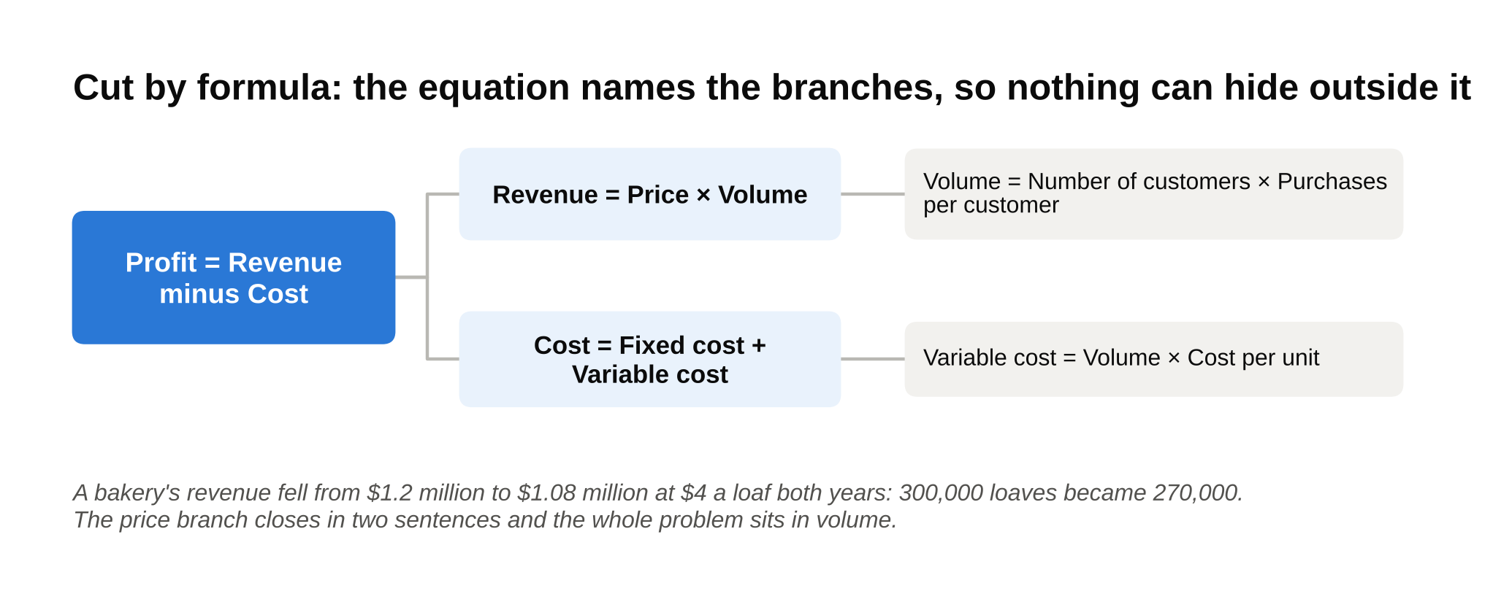
A formula tree is MECE by construction: profit splits into revenue and cost, revenue into price and volume, and the bakery example closes the price branch in two sentences.

Here's the smallest possible version. A bakery's revenue fell from $1.2 million to $1.08 million. Revenue is price times loaves. The price was $4 a loaf both years. So loaves went from $1,200,000 ÷ $4 = 300,000 to $1,080,000 ÷ $4 = 270,000. The whole problem is in the volume branch, down 10 percent, and the price branch is closed. Two sentences and you've eliminated half the tree.

Cut by formula whenever the prompt asks why a number changed, because an equation can't leave a gap and can't overlap with itself. Where it fails: when the question is a decision rather than a number. "Should we enter Mexico?" has no equation on top. You'll build the financial branch of that tree by formula, but the tree itself needs another cut. It also fails when you pick a formula that hides the real driver. "Revenue equals price times volume" is fine for a bakery with one product. For a company with five products at five prices, a shift in mix changes the average price without any price changing, so split volume by product first and apply the formula inside each.

Cut by process or sequence

Follow the thing that moves through the business: a customer, an order, a patient, a dollar. Each step in its path is a branch. A problem has to happen at one step, so the steps can't overlap, and if you've listed every step from start to finish there's no gap.

- Orders = Visits × Add-to-cart rate × Checkout-start rate × Payment-completion rate
- Step 1: Visits to the site (traffic)
- Step 2: Visitor adds an item to the cart (product page)
- Step 3: Visitor starts checkout (cart page)
- Step 4: Visitor completes payment (checkout page)
- After the order: delivery, returns, repeat purchase

An online retailer gets 1,000,000 visits a month. 10 percent add something to the cart, half of those start checkout, and 90 percent of those finish paying. Orders: 1,000,000 × 0.10 × 0.50 × 0.90 = 45,000. This month orders are 36,000. Walk the steps. Visits are still 1,000,000, add-to-cart is still 10 percent, payment completion is still 90 percent, but the share of cart holders who start checkout fell from 50 percent to 40 percent: 1,000,000 × 0.10 × 0.40 × 0.90 = 36,000. The leak is on the cart page, and you know that before anyone mentions a shipping fee.

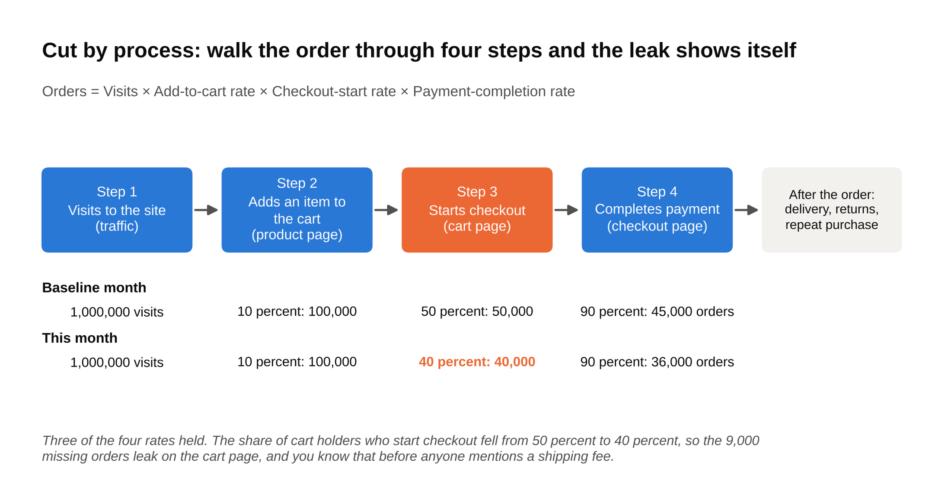
Lay the two months side by side step by step and only one rate moved: checkout starts fell from 50 to 40 percent, which is the whole 9,000 order gap.

Cut by process whenever something flows, because a flow has a first step and a last step and everything in between. Where it fails: when one cause hurts several steps at once. A slow website hurts every step, so if you organize your causes by step you'll end up discussing the same cause under four branches, which is an overlap of causes even though the steps are exclusive. The fix is to use steps for the diagnosis (which step leaks) and switch to causes for the fix.

Cut by segment

Customer, product, geography, channel. Pick one dimension and slice the whole business along it. One dimension per level is the rule that keeps this cut MECE.

- Revenue of a sneaker brand: $600 million
- By channel
- The brand's own stores: $200 million
- Wholesale, sold through other retailers: $300 million
- Online, direct to the customer: $100 million
- By geography (the next level, one new dimension)
- United States: $70 million
- International: $30 million

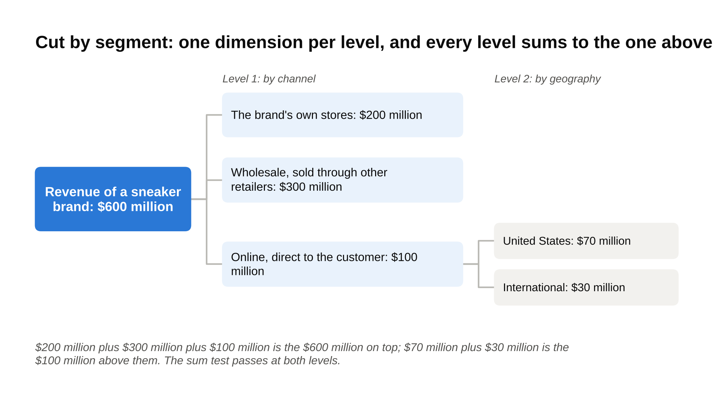
Channel on one level and geography on the next: the three channels add to $600 million and the two regions add to the $100 million of online sales above them.

The three channel branches add to $600 million. The two geography branches add to the $100 million above them. You can keep going (online international by country, then by product line) and every level still sums to the one above it.

Cut by segment when you suspect the problem lives in one part of the business, because the slices will show you which part. Where it fails: when the problem is everywhere. If every segment is down 10 percent, slicing told you nothing, and you've cut the symptom instead of the cause. Switch to formula or process. The other failure is mixing dimensions in one row: "stores, wholesale, international" puts a channel list next to a geography, and a wholesale sale in Canada now lives in two branches.

Cut by opposites

Internal versus external. New versus existing. Fixed versus variable. One-time versus recurring. Things we control versus things we don't. A real pair of opposites is MECE by definition, because every item is one or the other and nothing is both.

- Why did a regional airline's on-time rate fall from 85 percent to 75 percent?
- Causes inside the airline (things it controls)
- Crew scheduling: crews timing out, late connections between flights
- Maintenance: planes held at the gate for repairs
- Turnaround: boarding, fueling, and baggage running long
- The schedule itself: too little time planned between flights
- Causes outside the airline (things it doesn't control)
- Weather
- Air traffic control delays
- Airport congestion and gate availability
- Late inbound planes from partner airlines

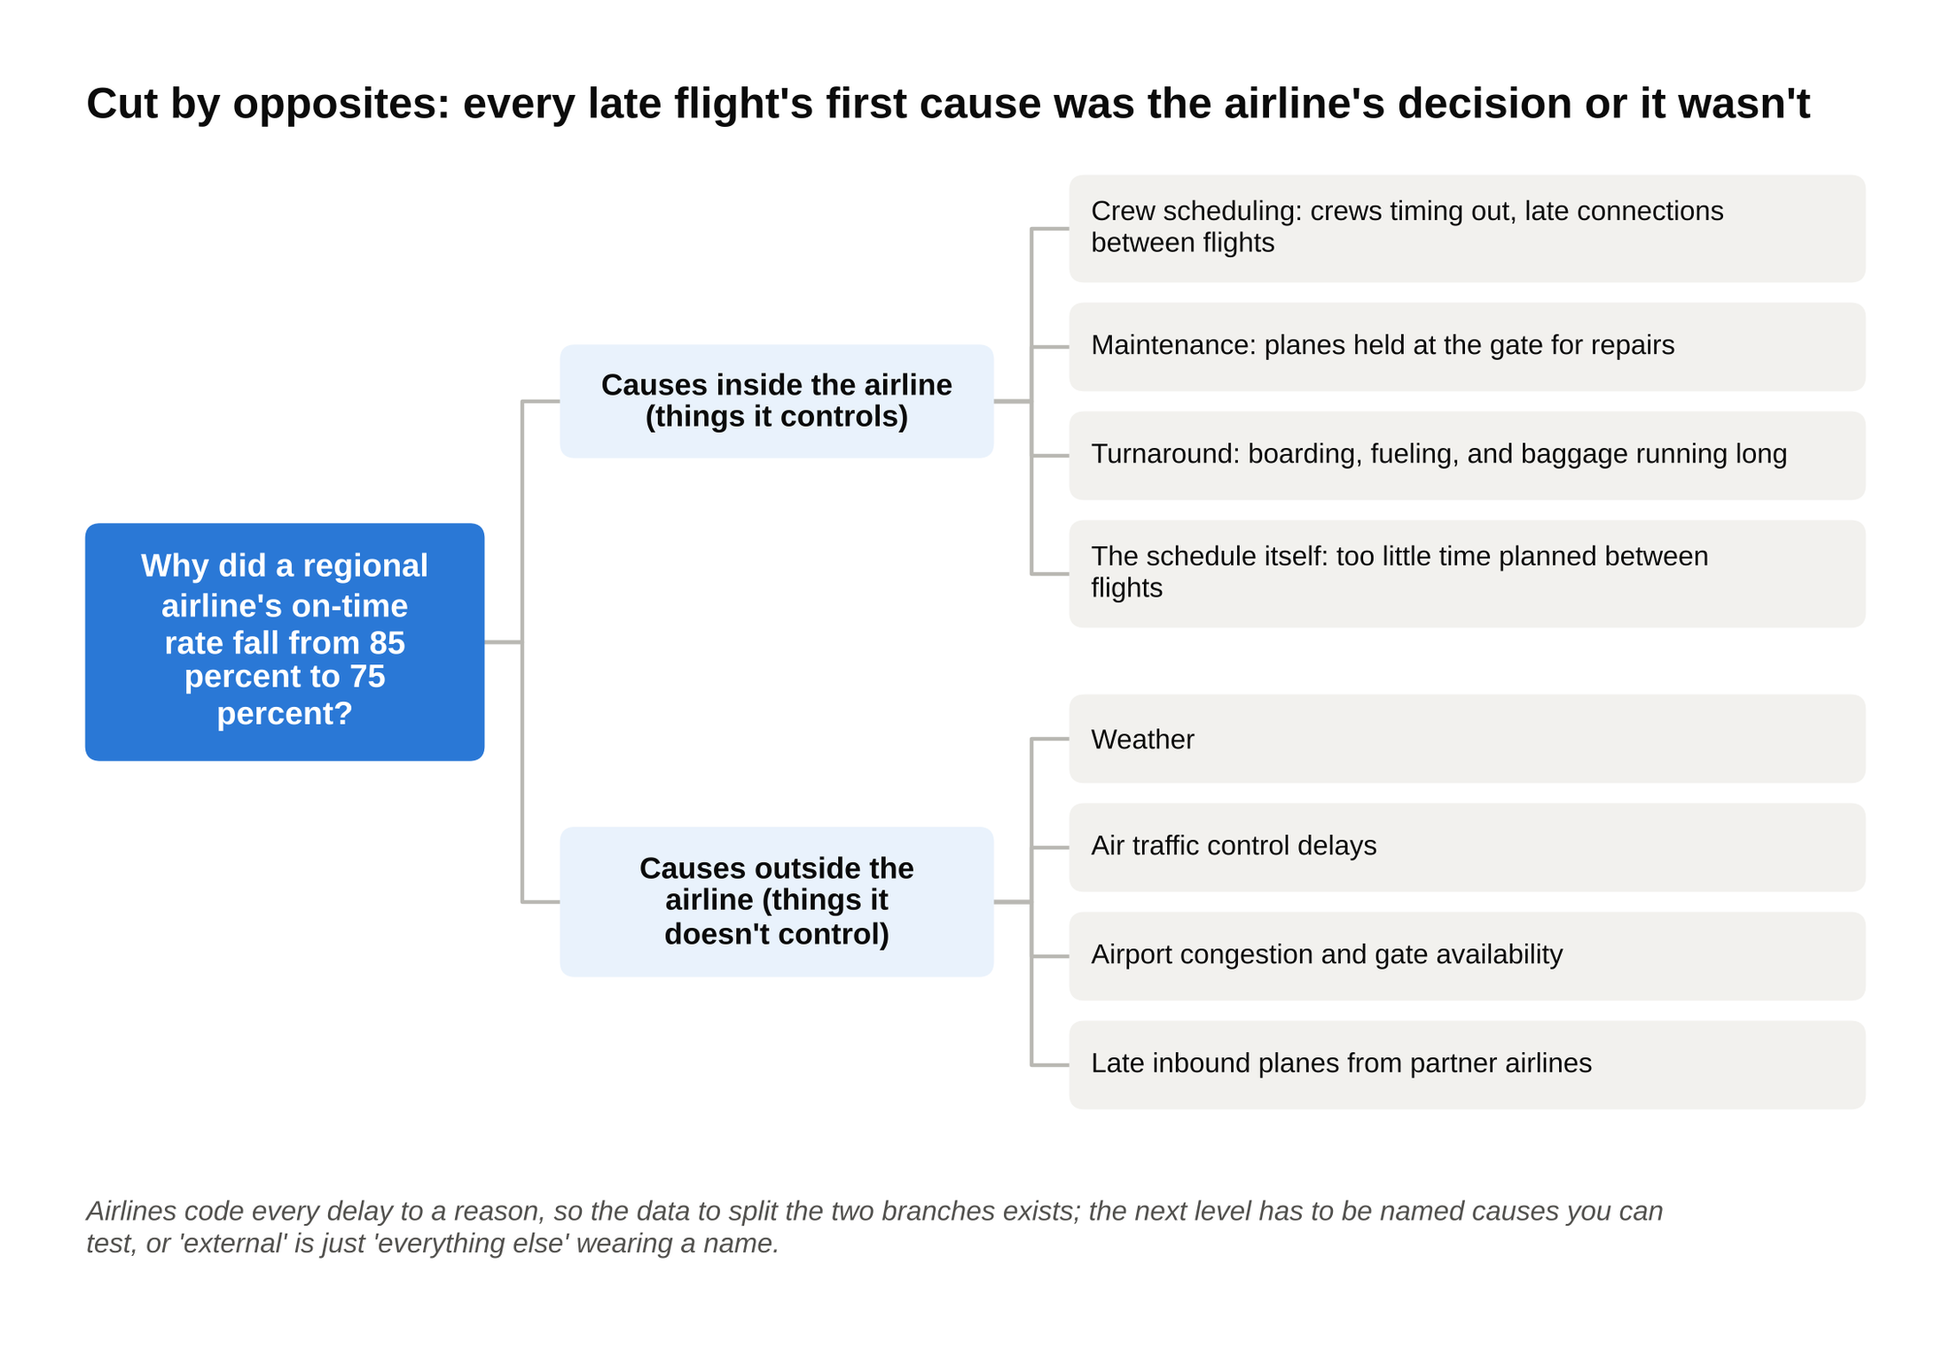
Inside versus outside gets you to full coverage in one line, and the four named causes under each branch are what make it a structure instead of a label.

Every late flight has a first cause, and that cause was either the airline's decision or it wasn't. The data to split it exists: airlines code every delay to a reason, and a case interviewer will usually hand you that table once you've asked for it by branch.

Cut by opposites as the first move on a problem you know nothing about, because it gets you to full coverage in one line. Where it fails: an "opposites" branch is often "everything else" wearing a name. "External" can hide ten unrelated things, so the next level has to be real, with named causes you can test, or the branch is a label and not a structure.

In a live case you'll stack the cuts: a formula at the top, a segment split underneath, a process split under that. One cutting logic per level is what keeps the stack MECE.

4. The two tests: overlap and gap, run in 30 seconds
A tree isn't MECE because you drew it carefully. It's MECE because it passed two tests, and in an interview you have about 30 seconds to run both before you say "here's how I'd structure this." Here's the routine.

The overlap test: pick three real items and drop each one into the tree. Take a tree for "how our bank reaches customers": branches, call center, app, email, social media, paid ads. Drop in a real item: a paid ad on Instagram. It lands in "social media" and in "paid ads." Overlap. Drop in a second: a push notification. App. Fine. A third: a billboard. Paid ads. Fine, but the first one already failed the test, so the tree needs a redraw. The fix is one dimension per level: channels the bank owns (branches, call center, app, email, its own social accounts) versus channels it pays for (search ads, social ads, billboards, TV). Now the Instagram ad has one home.

The gap test: try to invent something the tree can't hold, and if you can, there's a gap. Take "why did a bookstore's profit fall": fewer customers, lower prices, higher rent. Invent a cause. "Customers still come but buy fewer books each." Not fewer customers, not lower prices, not rent. Gap. Invent another. "Wages went up." Gap again. The tree was three causes someone thought of, not a structure. Rebuild it by formula: profit is revenue minus cost, revenue is customers times books per customer times price per book, cost is rent plus wages plus the cost of the books plus everything else, named. Now try to invent a cause that fits nowhere. You can't.

The sum test, for any tree made of numbers: the branches must add up to the number on top, or something is double counted or missing. $200 million plus $300 million plus $100 million equals the $600 million above them. If your branches sum to $640 million, two of them overlap. If they sum to $560 million, you have a gap worth $40 million.

If you read nothing else in this article, run those three on the next tree you draw. For the full routine of the first five minutes of a case, including where the tests fit, see how to structure a case study answer under pressure. Here are five trees run through the tests.

Prompt | Branches | Verdict | Why
Who flies our airline? | Business travelers, leisure travelers, families | Overlap | A family on vacation is leisure and family at once.
Why did a bookstore's profit fall? | Fewer customers, lower prices, higher rent | Gap | Fewer books per customer and higher wages fit nowhere.
How does our bank reach customers? | Branches, call center, app, email, social media, paid ads | Overlap | A paid Instagram ad is social media and a paid ad.
Where does a hospital's spending go? | Staff, supplies and drugs, buildings and equipment, everything else (named: insurance, IT, outside contracts) | Pass | Every dollar lands in one line, and "everything else" is a short named list, not a dump.
Why did a product launch flop? | Product, price, place, promotion | Gap | A competitor launching the same week, or a recession, fits none of the four.

That last row is worth a second look. The 4Ps are a famous marketing checklist and they're MECE for the things a company controls about a launch. They say nothing about the world outside the company, so as a tree for "why did this flop" they have a hole exactly where the answer often is.

5. Four worked issue trees, with the arithmetic shown
Reading about MECE does nothing.

Watching a tree get built, filled with numbers, and used to pick a branch is what sticks. Here are four, one per common case type, each with the prompt, the tree, the data, the math, and the branch I'd chase first. The companies are made up and every number ties. A worked issue tree earns its keep when every level adds up to the one above it and the numbers tell you which branch to open first.

Tree 1: a profitability case (a casual dining chain)

The prompt: "Our client runs 150 casual dining restaurants across the Southeast. Over two years, operating profit fell from $22.5 million to $8.6 million while revenue barely moved. The CEO wants to know why and what to do."

Clarifying questions worth asking: Is it still 150 restaurants in the same towns? (Yes, no openings or closings.) Did menu prices change? (Up about 4 percent.) Is operating profit before interest and tax? (Yes.)

The tree, cut by formula at the top and by cost line underneath:

- Operating profit fell $13.9 million, from $22.5 million to $8.6 million
- Revenue fell $2.7 million, from $225.0 million to $222.3 million
- Volume: covers (meals served) per restaurant fell from 60,000 to 57,000 a year
- Price: the average check rose from $25 to $26
- Costs rose $11.2 million, from $202.5 million to $213.7 million
- Food and beverage: $67.5 million to $71.1 million, up $3.6 million
- Labor: $72.0 million to $77.6 million, up $5.6 million
- Hours worked: 4.80 million to 4.85 million
- Wage rate: $15.00 to $16.00 an hour
- Occupancy (rent, utilities, insurance): $27.0 million to $28.4 million, up $1.4 million
- Other (marketing, supplies, head office): $36.0 million to $36.6 million, up $0.6 million

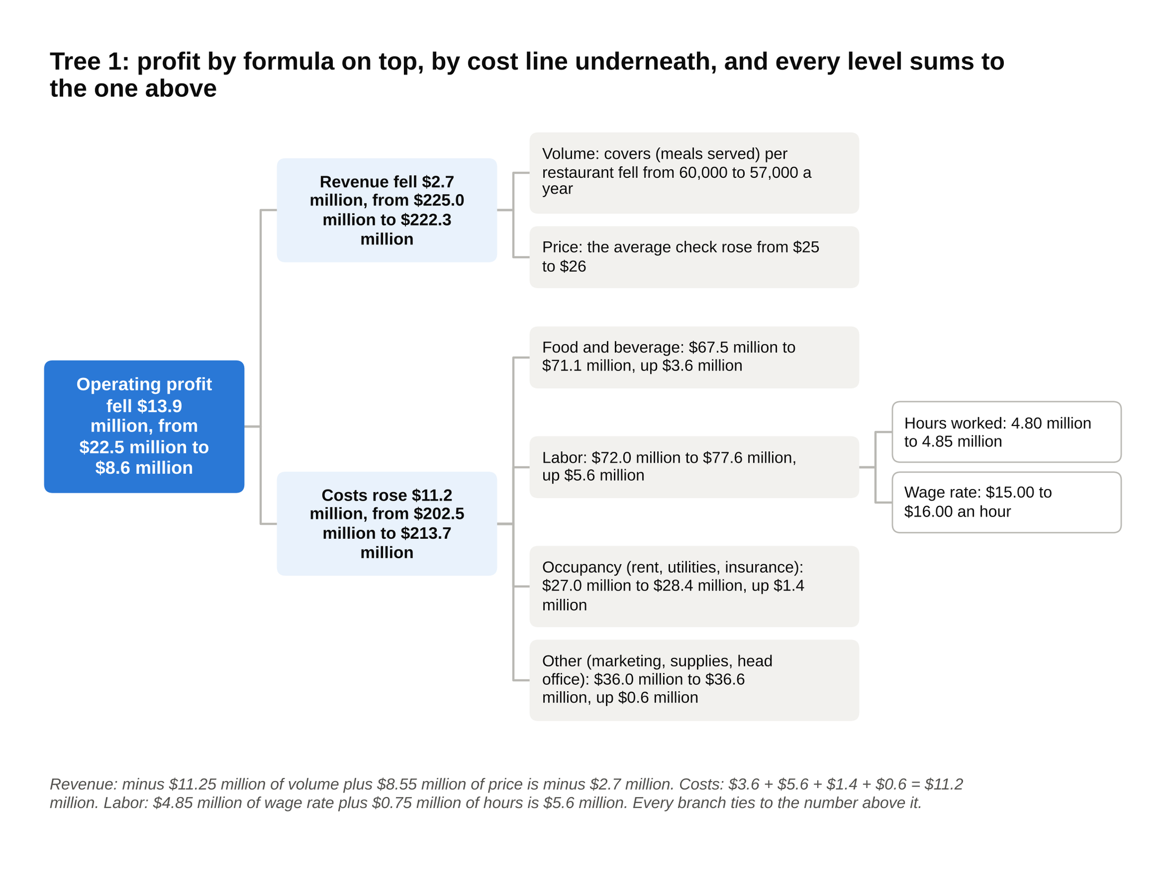
Every line on the chain's profit and loss statement has one home in this tree, and the labor branch splits again into hours and wage rate so you can see which part the client controls.

Every item on the chain's profit and loss statement has one home in that tree, and every level sums to the one above it. Here is the data the interviewer hands over.

Line | Two years ago | Today
Restaurants | 150 | 150
Covers per restaurant per year | 60,000 | 57,000
Average check | $25.00 | $26.00
Revenue | $225.0 million | $222.3 million
Food and beverage | $67.5 million | $71.1 million
Labor | $72.0 million | $77.6 million
Occupancy | $27.0 million | $28.4 million
Other | $36.0 million | $36.6 million
Total cost | $202.5 million | $213.7 million
Operating profit | $22.5 million | $8.6 million
Operating margin | 10.0 percent | 3.9 percent

The math:

- Revenue two years ago: 150 × 60,000 × $25 = $225.0 million. Today: 150 × 57,000 × $26 = $222.3 million. Down $2.7 million.
- Split the revenue change into the two branches. Volume effect: 3,000 fewer covers per restaurant × 150 restaurants = 450,000 fewer covers, × the old $25 check = minus $11.25 million. Price effect: $1 more per check × today's 8.55 million covers (150 × 57,000) = plus $8.55 million. Minus $11.25 million plus $8.55 million = minus $2.7 million. The branches tie to the top.
- Costs: $67.5 + $72.0 + $27.0 + $36.0 = $202.5 million two years ago; $71.1 + $77.6 + $28.4 + $36.6 = $213.7 million today. Up $11.2 million. By line: food $3.6 + labor $5.6 + occupancy $1.4 + other $0.6 = $11.2 million. Ties.
- "Other" is about 17 percent of today's cost ($36.6 ÷ $213.7), which is over the 10 percent line I give later for splitting an "other" bucket. It stays one branch here because it's named and it barely moved ($0.6 million). If it had moved, you'd split it into marketing, supplies and head office before asking for data.
- Profit: $225.0 minus $202.5 = $22.5 million; $222.3 minus $213.7 = $8.6 million. The $13.9 million drop is $2.7 million of revenue plus $11.2 million of cost. Operating margin (profit as a share of revenue) went from 10.0 percent to 3.9 percent ($8.6 ÷ $222.3).
- Labor, split by its own formula: 4.80 million hours × $15 = $72.0 million; 4.85 million hours × $16 = $77.6 million. Wage effect: $1 × 4.85 million hours = $4.85 million. Hours effect: 50,000 extra hours × $15 = $0.75 million. $4.85 plus $0.75 = $5.6 million. Ties.
- The tell is in the hours. Covers fell 5 percent (9.0 million to 8.55 million) but hours worked rose 1 percent. Hours per cover went from 0.533 to 0.567, up about 6 percent. The restaurants kept staffing for a crowd that stopped coming.
- Food cost per cover: $67.5 million ÷ 9.0 million = $7.50; $71.1 million ÷ 8.55 million = $8.32, up 11 percent while the check rose 4 percent. Food went from 30.0 percent of revenue to 32.0 percent.

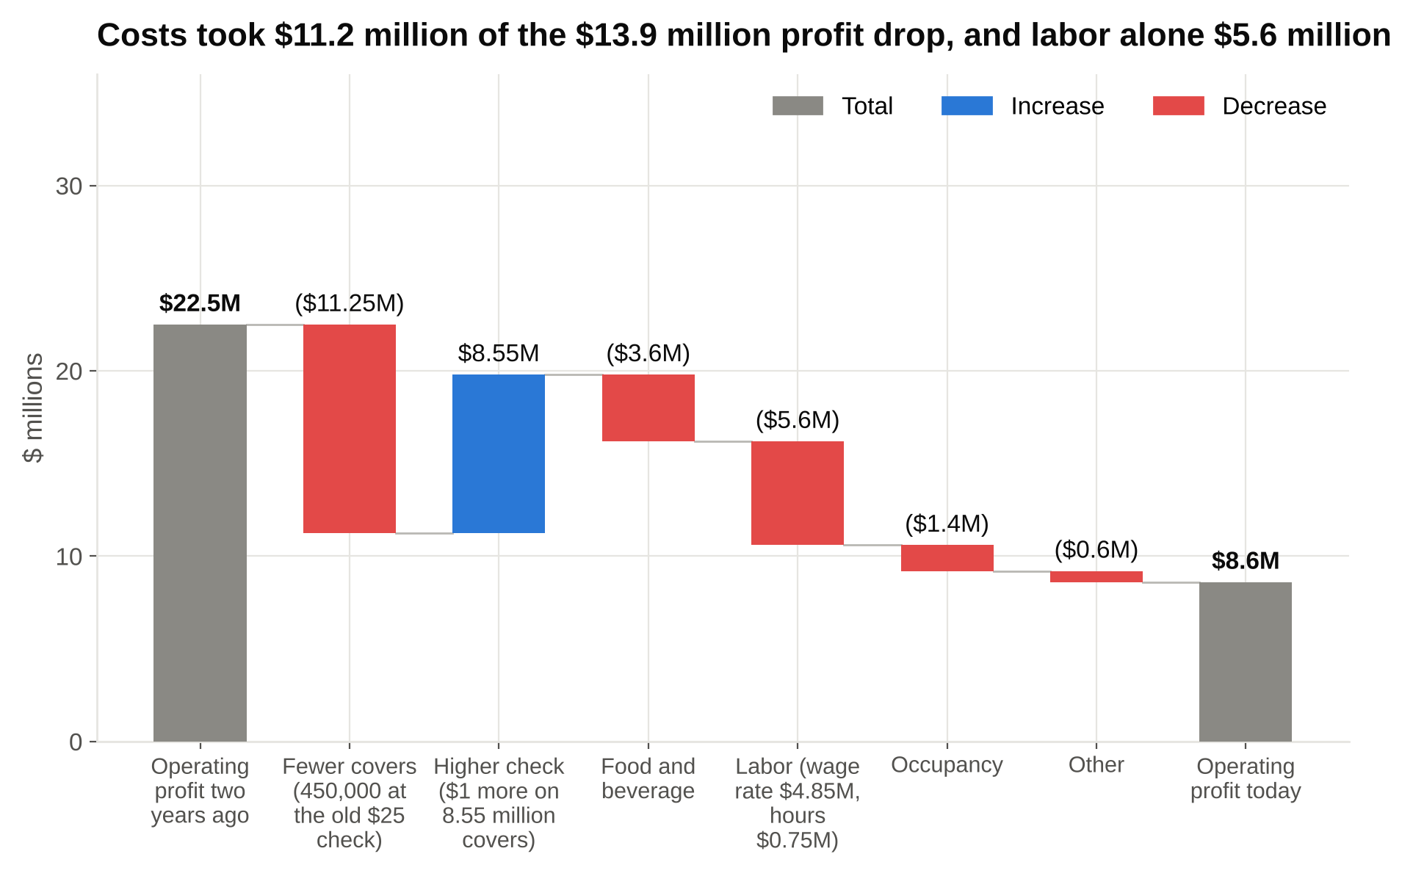
Walk the bridge left to right and the revenue branch nearly nets out, so the $13.9 million drop is mostly the four cost lines, with labor the biggest of them.

Which branch to chase, and why: The cost side holds $11.2 million of the $13.9 million, so that's where the case lives. Inside cost, labor is the biggest mover at $5.6 million, but most of it ($4.85 million) is the wage rate, and a restaurant chain doesn't set the local wage. The piece the client controls is hours. Had hours fallen 5 percent with covers, labor would be 4.56 million hours × $16 = $72.96 million, about $4.6 million less than today. Food is the second branch: holding food at 30 percent of today's revenue would be $66.7 million, about $4.4 million less than today. Those two controllable fixes recover roughly $9 million of the $13.9 million. In a profitability tree, chase the branch that is both big and controllable, which is usually not the branch that is biggest. The revenue branch is a real but smaller story: a 4 percent price increase with a 5 percent volume loss means customers noticed the price, and the next price move should wait until the cost side is fixed.

Tree 2: a market entry case (premium dishwashers)

The prompt: "Our client makes premium dishwashers in Germany and sells across Europe. It has no US presence. Should it enter the US market?"

Clarifying questions: What counts as premium? (Machines over $1,200.) What's the goal: revenue or profit? (Profit within five years.) Any constraint on how they enter? (None yet.)

The tree, cut into the four questions every entry decision turns on:

- Should the client enter the US premium dishwasher market?
- Is the market worth entering?
- Size: about 8 million dishwashers sold a year at an average $800, so $6.4 billion; premium is 15 percent of units, 1.2 million units at about $1,500, so $1.8 billion
- Growth: premium growing about 5 percent a year, so roughly 1.5 million units by year five
- Competition: who holds premium today, and how they'd respond to a new entrant
- Customers: what US buyers want (24-inch width, a third rack, drying performance, fast repairs)
- Can the client win there?
- Product fit: does the European lineup fit US kitchens and habits
- Brand: awareness among US buyers is close to zero today
- Distribution: appliance chains, kitchen designers, home builders
- Service: repairs within days, parts stocked in the US
- Does the math work?
- Revenue at a 10 percent premium share in year five: 150,000 units × $1,500 = $225 million
- Gross margin (what's left of the price after making and shipping each machine): 28 percent in the US after shipping and import costs, against 35 percent at home, so $63 million
- Fixed US costs: sales team, marketing, service network, about $45 million a year
- Operating profit in year five: $63 million minus $45 million = $18 million
- Investment to get there: about $120 million over five years (early losses, warehouses, showrooms, service)
- Payback (how many years of profit it takes to earn the investment back): $120 million ÷ $18 million = about 6.7 years, counted from year five
- How would they enter, and what could go wrong?
- Build it alone, partner with a US retailer, or buy a small US brand
- Risks: tariffs, a price response from incumbents, early service failures that kill the brand

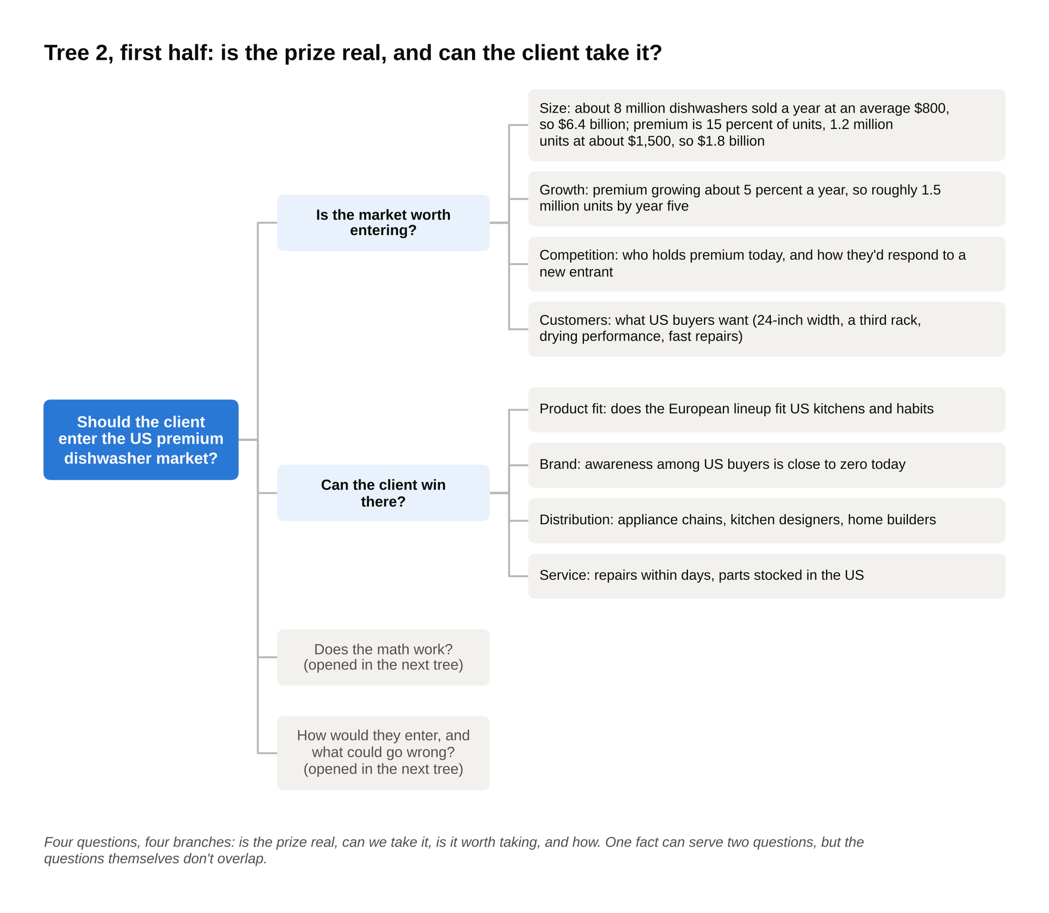
The first two questions of the entry tree: the premium segment is $1.8 billion, and the client's brand awareness in the US is close to zero.

The four top branches are MECE because they're four different questions: is the prize real, can we take it, is it worth taking, and how. Nothing you'd want to ask about a market entry fits outside them. One fact can serve two questions (that incumbents might cut prices tells you about competition when you size the market, and about risk when you plan the launch), but it answers a different question in each place, so the branches themselves don't overlap.

The math, and the number the case turns on:

- Premium segment today: 8 million × 15 percent = 1.2 million units; × $1,500 = $1.8 billion.
- Year five at 10 percent share: 150,000 units × $1,500 = $225 million revenue; × 28 percent = $63 million gross profit; minus $45 million fixed = $18 million operating profit. Payback on $120 million: 6.7 years. Weak.
- Year five at 15 percent share: 225,000 units × $1,500 = $337.5 million; × 28 percent = $94.5 million; minus $45 million = $49.5 million. Payback: $120 million ÷ $49.5 million = 2.4 years. Strong.

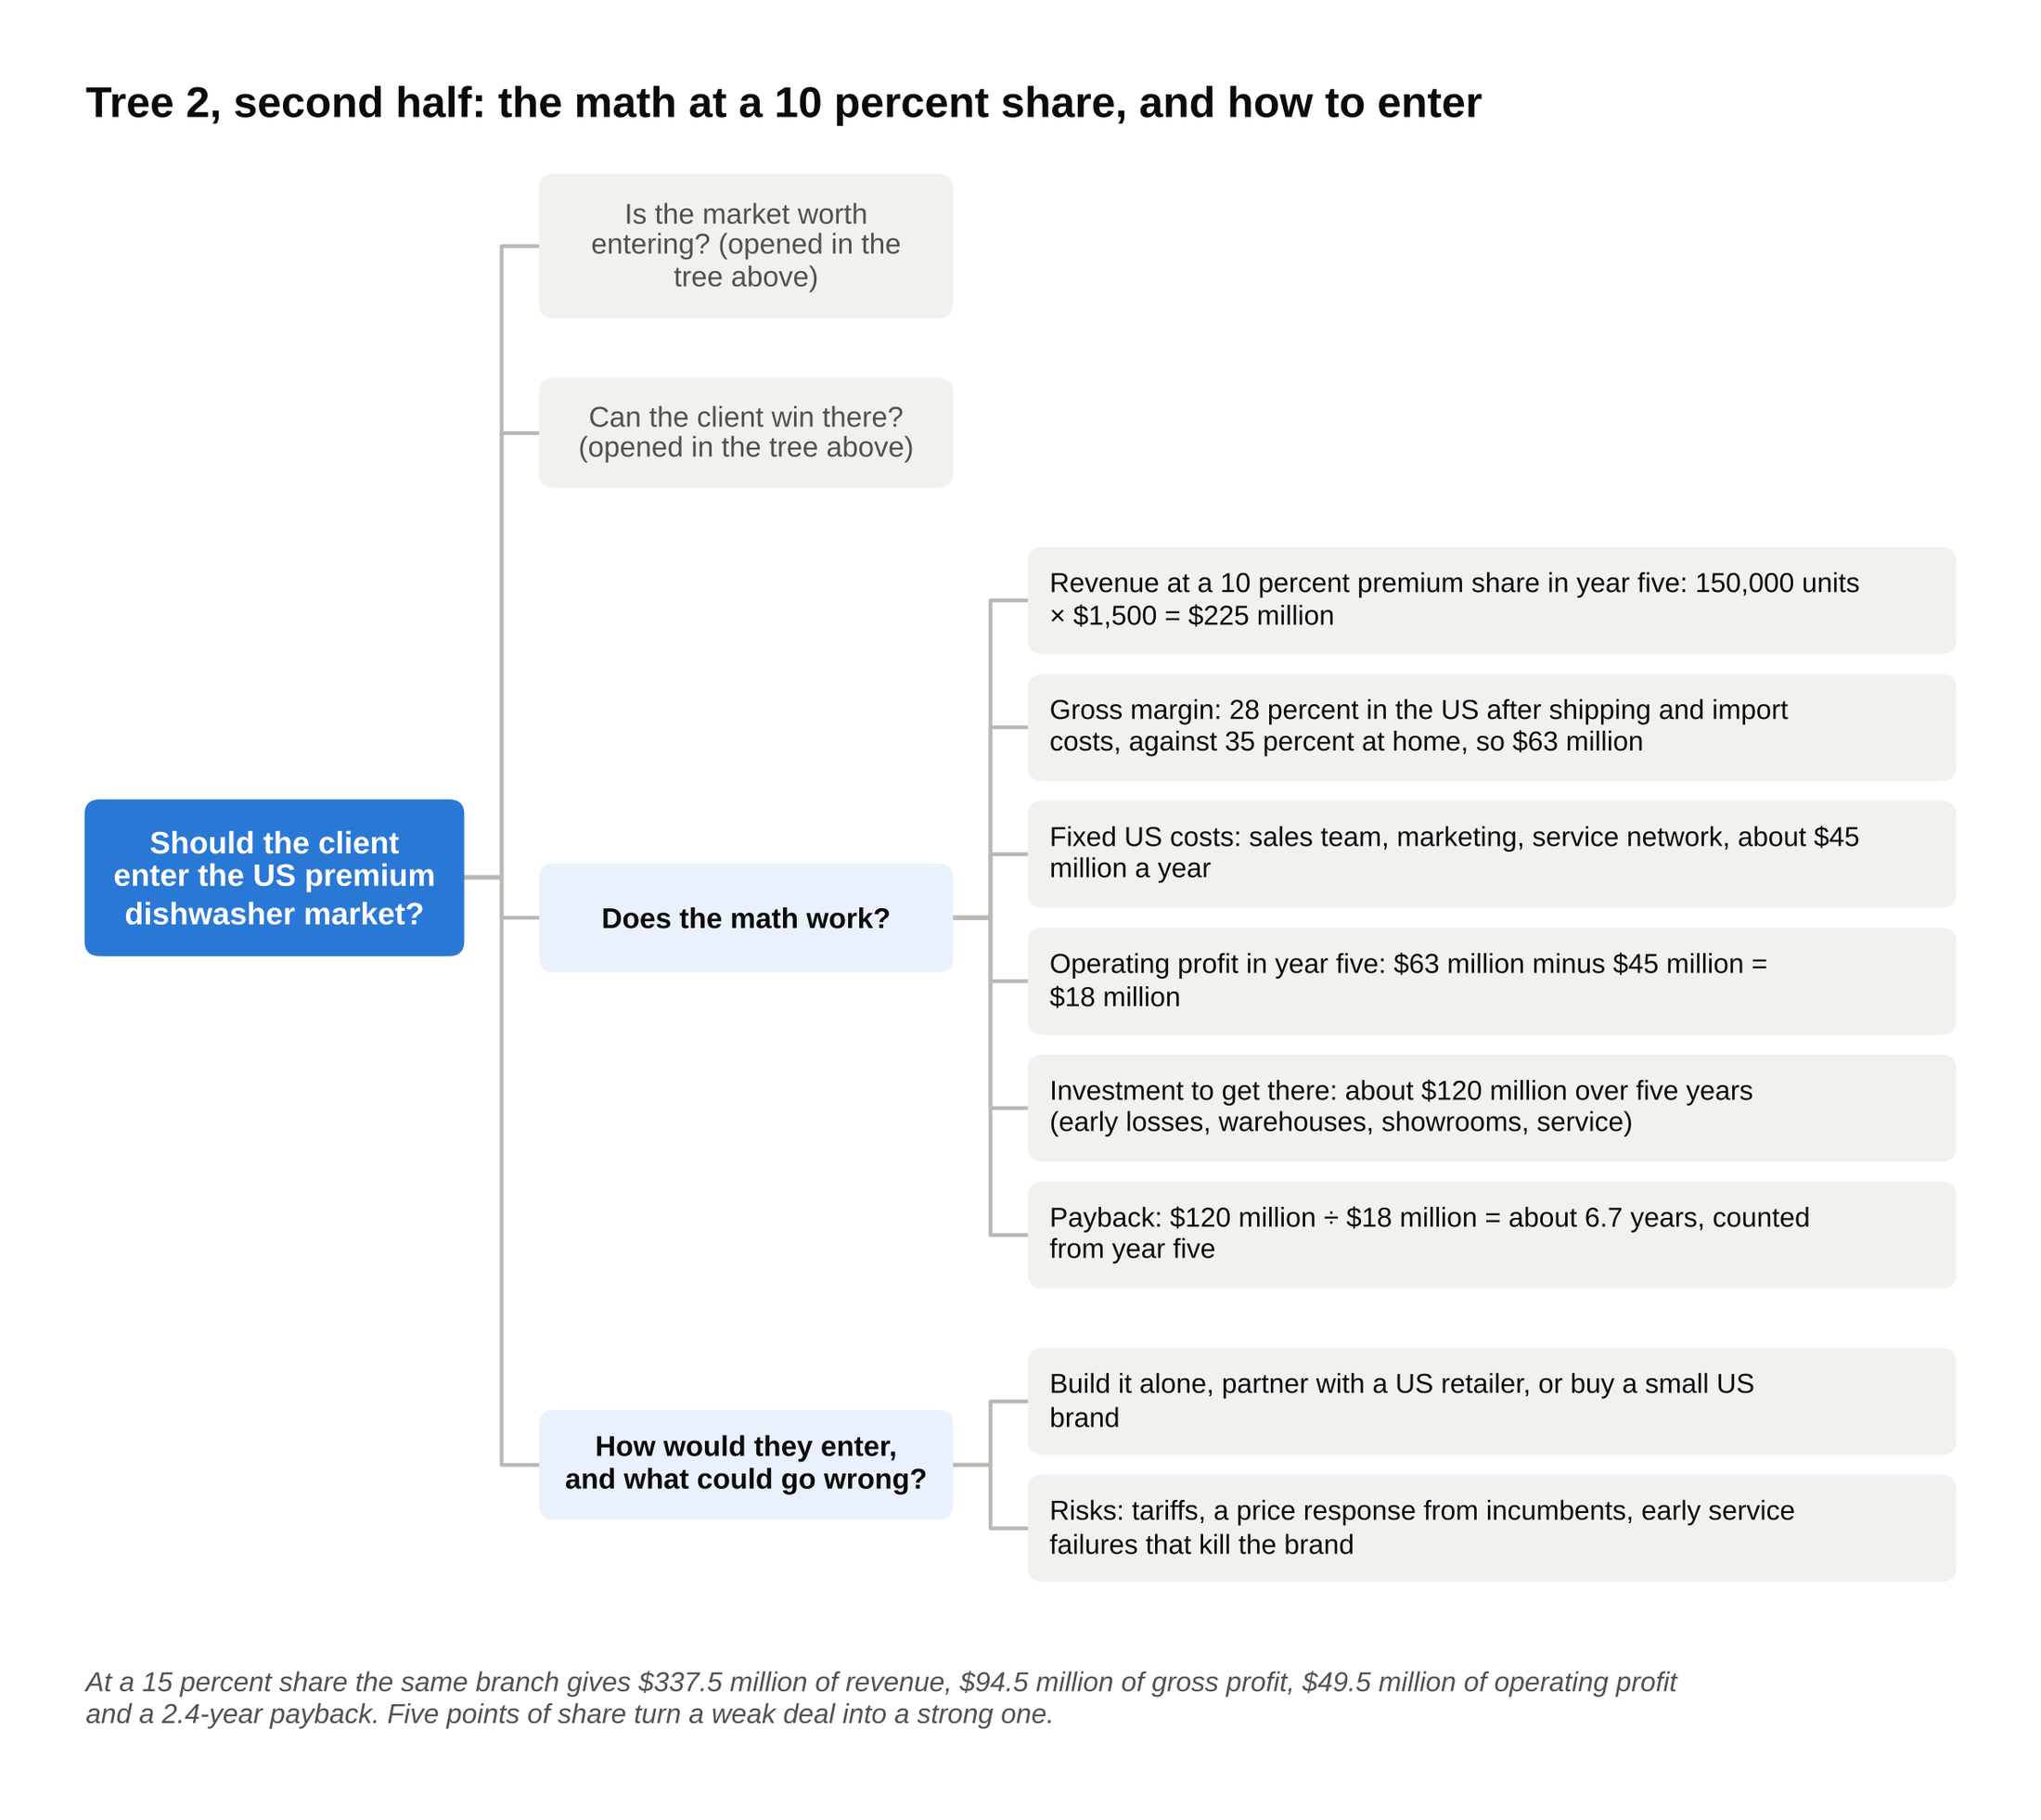
The math branch pays back in 6.7 years at a 10 percent share and 2.4 years at 15, so the case turns on the share question, which lives in the branch above.

Which branch to chase, and why: "Can the client win." The math branch swings from a bad deal to a good one on five points of share, so the whole case is whether a brand nobody in the US has heard of can take 15 percent of the premium segment in five years without its own stores or service trucks. That's a distribution and service question, which is why the entry mode matters more here than the market size. In a market entry tree, find the single input the financial branch is most sensitive to, then spend the case on the branch that decides that input. My recommendation would be to enter only through a partnership that brings distribution and service on day one, with a kill point at the end of year two if share is under 5 percent.

Tree 3: a revenue growth case (a dental chain)

The prompt: "Our client owns 40 dental practices in the Midwest with $120 million in revenue. The owners want $150 million within three years. How do they get there?"

Clarifying questions: Is the $150 million a revenue target or a profit target? (Revenue, with margins held.) Can they buy practices? (Yes, if it pays back.) Anything off limits? (No.)

The tree, cut first by existing versus new practices, then by formula:

- Grow revenue from $120 million to $150 million (plus $30 million)
- Revenue from the 40 practices they own today ($120 million now)
- More active patients (100,000 today, 2,500 per practice)
- More new patients in: referrals, online booking, joining more insurance networks
- Fewer patients lost: reminders, a better visit
- More visits per patient (2.0 a year today)
- Recall compliance: getting the patient back for the second cleaning of the year
- More revenue per visit ($600 today)
- Treatment accepted at the visit (fillings, crowns, aligners) versus a cleaning alone
- Price and insurance contracts
- Revenue from practices they don't own yet ($0 now)
- Open new practices
- Buy existing practices

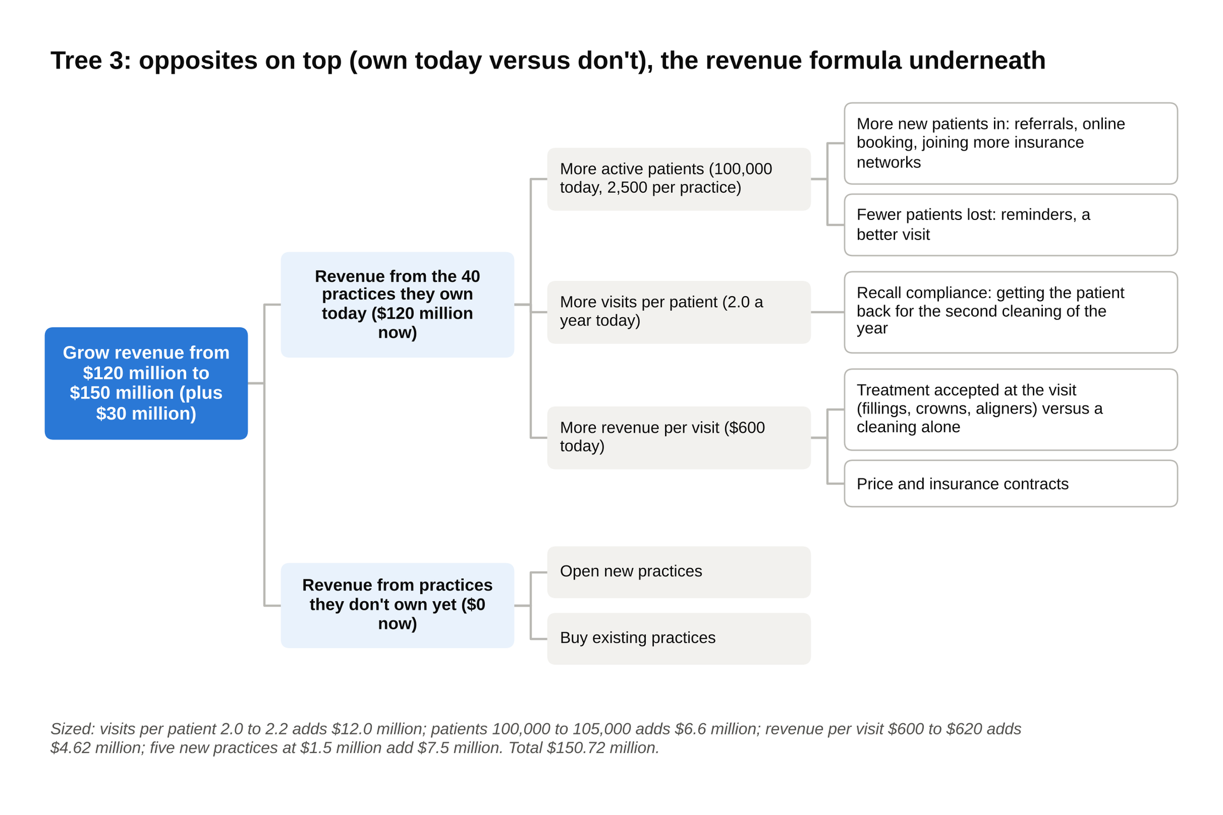
The top split is opposites and the existing-practice branch is the revenue formula, so any dollar of new revenue has exactly one home in this tree.

The top split is opposites (own today versus don't), and the existing-practice branch is the revenue formula: patients × visits per patient × revenue per visit. Any dollar of new revenue has exactly one home.

The math:

- Today: 100,000 patients × 2.0 visits × $600 = $120.0 million, or $3.0 million per practice.
- Lever 1, recall: visits per patient from 2.0 to 2.2. 100,000 × 2.2 × $600 = $132.0 million, plus $12.0 million.
- Lever 2, patients: 100,000 to 105,000, a 5 percent net gain after losses. 105,000 × 2.2 × $600 = $138.6 million, plus $6.6 million on top of lever 1.
- Lever 3, revenue per visit: $600 to $620 from more treatment accepted. 105,000 × 2.2 × $620 = $143.22 million, plus $4.62 million.
- Existing practices total: $143.22 million, up $23.22 million from today. Check: $12.0 + $6.6 + $4.62 = $23.22 million.
- Gap to the target: $150 million minus $143.22 million = $6.78 million. A practice bought or opened now does about $1.5 million a year by year three, half of a mature practice's $3.0 million. $6.78 ÷ $1.5 = 4.5, so five new practices: $7.5 million. Total: $143.22 + $7.5 = $150.72 million. Target met.

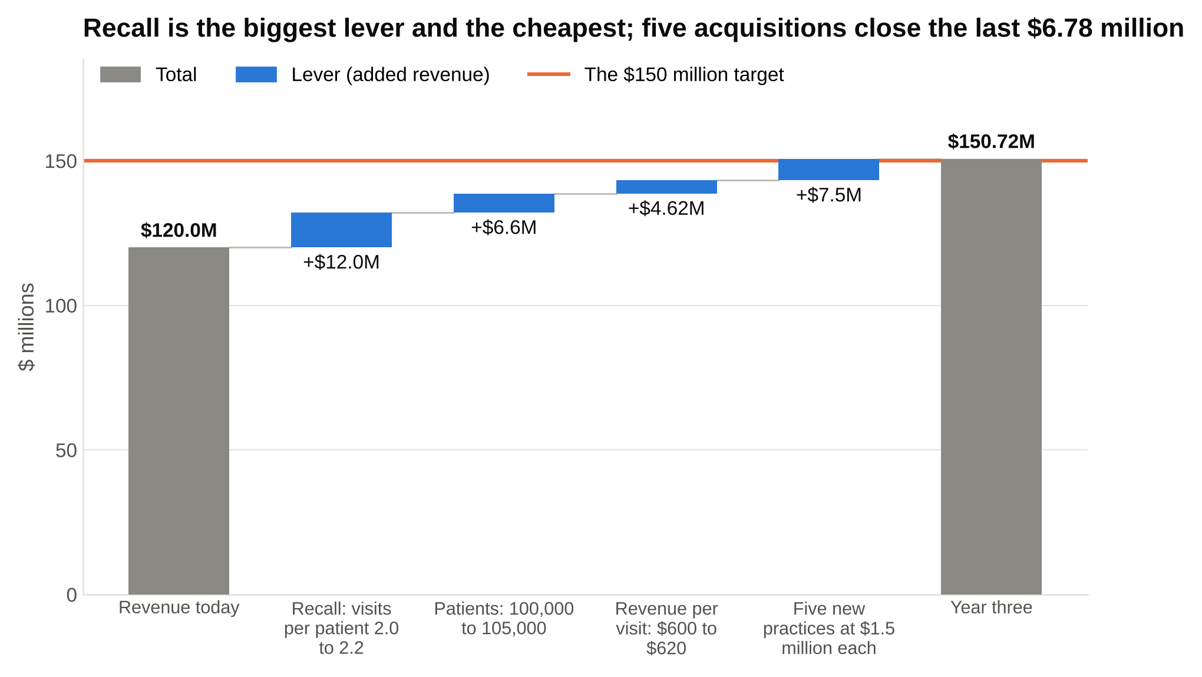
Size the levers before you rank them: recall adds $12 million for almost no money, and the acquisitions the owners called about add $7.5 million for the most capital and risk in the tree.

Which branch to chase, and why: Recall first. It's the biggest single lever ($12 million), it costs almost nothing (text reminders and booking the next visit before the patient leaves), and it needs no capital. New patients second. New practices last, even though the owners probably called because they wanted to talk about acquisitions: $7.5 million of revenue from five deals is the most capital and the most risk per dollar in the tree. In a growth tree, size every lever before you rank them, because the lever the client is excited about is rarely the biggest one.

Tree 4: an operations case (hospital operating rooms)

The prompt: "A 300-bed hospital's eight operating rooms are in use 55 percent of the hours they're staffed. The chief operating officer wants 75 percent without adding rooms. Where is the time going?"

Clarifying questions: How is "staffed" defined? (10 hours a day, 250 days a year.) How is "in use" measured? (Hours with a surgery in progress ÷ staffed hours.) Is the mix of surgeries changing? (No.)

The tree, cut by where in the day the empty hour sits:

- 9,000 idle operating room hours a year (20,000 staffed hours minus 11,000 hours of surgery)
- Before the first case: the first patient arrives after the scheduled start (late starts)
- Between cases: cleaning and set-up ("turnover") runs longer than the standard
- Reserved but unused: surgeons hold reserved time ("blocks") they don't fill, and release it too late for anyone else to use
- Cancelled on the day: the patient isn't ready, there's no bed for afterward, or the surgeon is unavailable
- End of day: a gap too short to fit another case

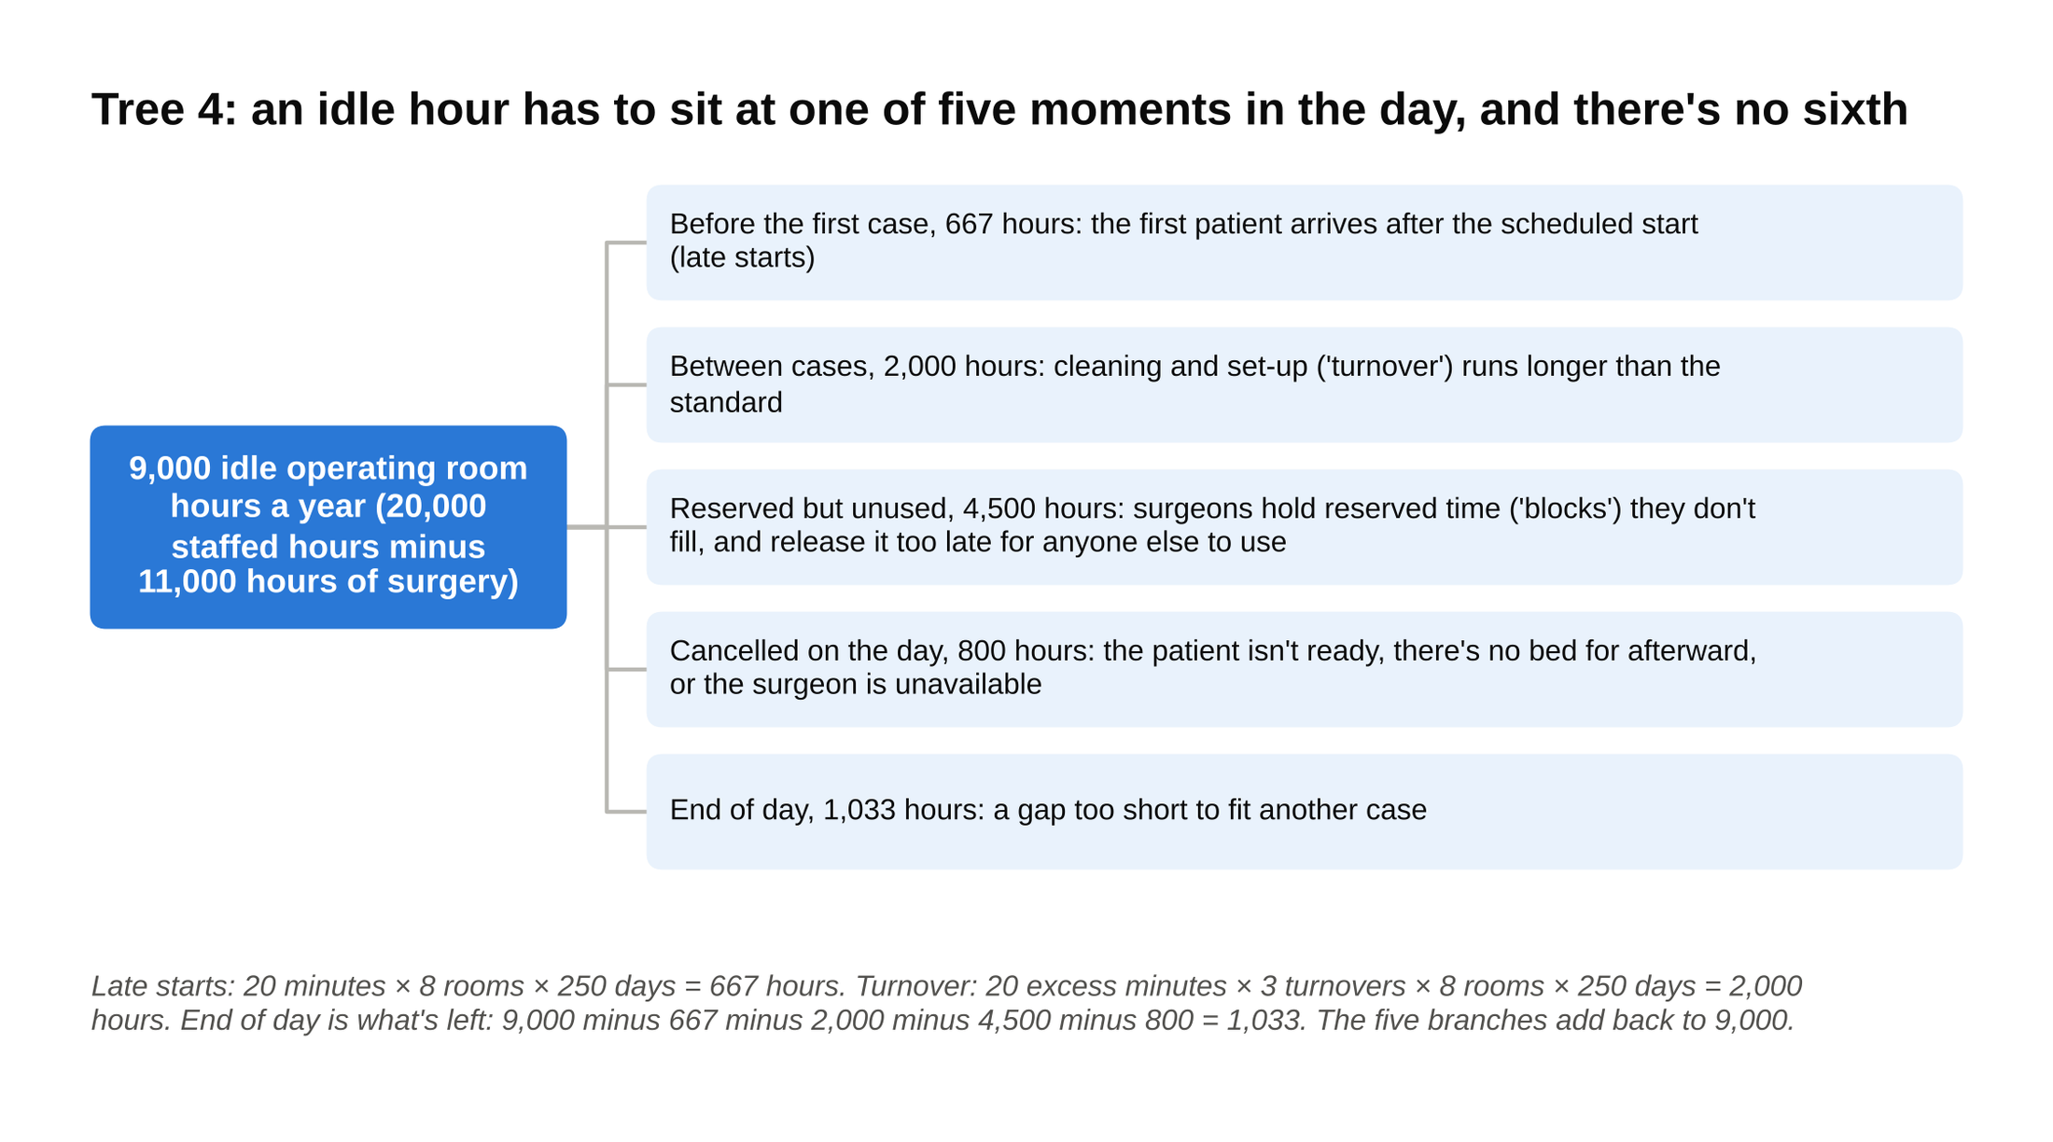
A process cut is MECE because an empty hour has to happen at one of these five moments, and sizing each branch shows that the loudest complaint, late starts, is the smallest bucket.

This is a process cut, and it's MECE because an empty hour in an operating room has to happen at one of those five moments: before the day's first case, in a gap between cases, inside a reserved block nobody used, in a slot a cancellation emptied, or after the last case ends. There's no sixth place for an idle hour to be.

The math:

- Staffed hours: 8 rooms × 10 hours × 250 days = 20,000. In use: 55 percent, so 11,000. Idle: 9,000. The target, 75 percent, is 15,000 hours in use, so the COO needs 4,000 hours back.
- Late starts: the first case starts 20 minutes late on average. 20 minutes × 8 rooms × 250 days = 40,000 minutes = 667 hours.
- Turnover: four cases per room per day means three turnovers, each running 45 minutes against a 25-minute standard. 20 excess minutes × 3 turnovers × 8 rooms × 250 days = 120,000 minutes = 2,000 hours.
- Reserved but unused: the scheduling system shows 4,500 hours of block time that was never filled.
- Same-day cancellations: 800 hours.
- End-of-day gaps: whatever is left. 9,000 minus 667 minus 2,000 minus 4,500 minus 800 = 1,033 hours.
- Check: 667 + 2,000 + 4,500 + 800 + 1,033 = 9,000. The branches tie to the top.

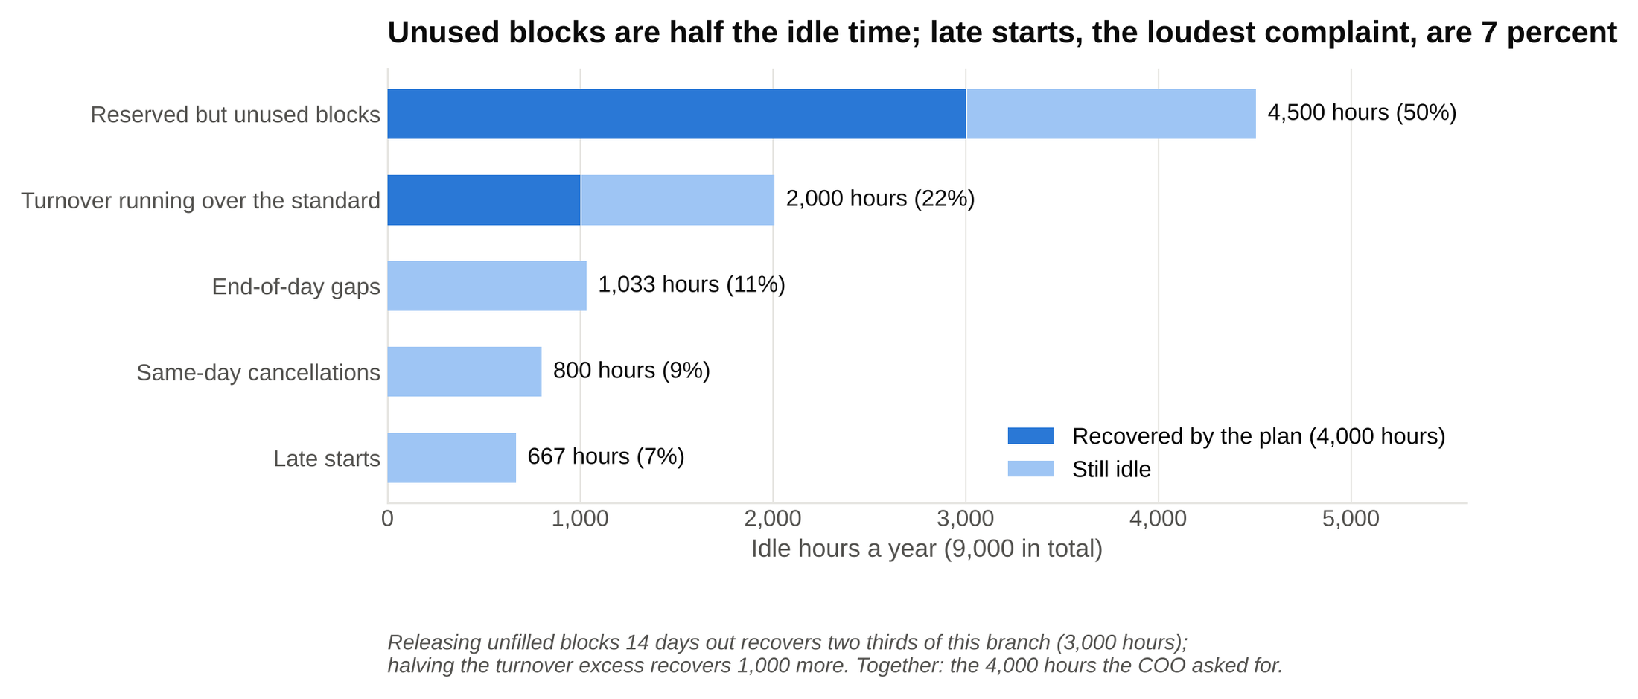
Size each bucket of waste before anyone proposes a fix: unused blocks hold 4,500 of the 9,000 hours, and the late starts every meeting argues about hold 667.

Which branch to chase, and why: Unused blocks are half the idle time, and the fix is a policy, not a building: release any block that isn't filled 14 days out instead of 3 days out, and show each surgeon their fill rate (the share of their reserved hours they actually used) every month. Recovering two thirds of that branch (3,000 hours) plus half the turnover excess (1,000 hours) is exactly the 4,000 hours the COO asked for. Late starts are the branch every hospital meeting argues about, and they're 7 percent of the problem. In an operations tree, size each bucket of waste before anyone proposes a fix, because the loudest complaint is usually the smallest bucket.

6. The seven ways an issue tree goes wrong
I see the same seven failures in mock cases, in roughly this order of frequency. Each one has a quick fix.

1. Overlap. "Why are costs up: labor, overtime, benefits, materials." Overtime and benefits are kinds of labor. The interviewer now doesn't know whether a nurse's extra shift goes in branch one or branch two. Fix: fold the sub-kinds under their parent. Labor (wages, overtime, benefits), materials, everything else.

2. Gaps. "Why did sales fall: price, competition." Where does a shrinking market go? A lost distributor? A product recall? Fix: start from the formula or the process, not from the two causes that came to mind first.

3. The "other" bucket. "Revenue: product A, product B, other," where "other" is 40 percent of the business. That passes the gap test by cheating. An "other" branch has to be small and named, or it's a sign the cut isn't finished. Fix: "other: parts and accessories, about 6 percent of revenue," and if it's bigger than 10 percent, split it.

4. A list instead of a tree. Twelve possible causes in one flat row. All twelve might be real, but with no levels the interviewer can't tell a cause from a sub-cause, and you can't say which one you'll test first. Fix: group the twelve into three or four parents, then say which parent you'd open.

5. Two cutting logics in one row. "Revenue: in-store, online, international, new customers." That row mixes channel, geography, and customer type. An online order from a new customer in Canada lives in three branches. Fix: one dimension per level. Channel on the first level, geography under each channel, customer type under that if you need it.

6. Seven branches when three would do. In 1956 a Harvard psychologist, George Miller, published a paper in Psychological Review arguing that people hold about seven items in short-term memory, give or take two. Later work by Nelson Cowan put the real number closer to four. Three to five branches at the top is the limit, because your interviewer is holding your tree in working memory while you talk. At seven branches, they've lost the first two by the time you reach the last, and so have you. A sophomore I coached last spring, call him R, opened every mock case with six or seven branches because he was afraid of leaving something out. We spent two weeks on one drill: build the seven, then merge until three remain and say what you merged and why. By his Bain final round in May he opened with three every time, and the offer came the next week. Fix: if you have more than five, two of them are the same kind of thing. Merge them.

7. A structure with no hypothesis. A hypothesis is the branch you'd bet on and test first. A perfect tree that ends with "and then I'd look at all of these" has none. The interviewer wants to know where you'd look first and why. At Bain and BCG especially, the structure is expected to end in a guess. Fix: close the structure with one sentence: "I'd start with labor, because it's the largest line and the prompt mentioned a wage increase."

Most failed trees fail on overlap or on branch count, and both get fixed by the same move: find the two branches that are the same kind of thing and merge them.

7. MECE at every level of the case, from the first minute to the last slide
Candidates treat MECE as an opening-structure rule and then forget it. In a real case it runs through every minute, and the interviewers grade it at each stop.

The opening structure. Everything above. Three to five branches, one cut per level, the two tests passed, a hypothesis at the end.

The hypotheses. One per branch, and each one testable with data the client could have. "Labor hours haven't fallen with volume" is a hypothesis you can check with a staffing report. "Something is off in operations" isn't. A hypothesis that spans two branches is your tree telling you those two branches overlap.

The analysis. Every data request you make should name the branch it's for. "To test the labor branch, can I see hours worked and the wage rate for both years?" An interviewer who hears the branch name knows you're still inside your structure. One who hears "do you have any other data?" knows you've left it.

The synthesis. When the interviewer says "so what have we learned," the answer is a MECE list with a number on each item: "Three reasons, no overlap. Costs are up $11.2 million, and $5.6 million of that is labor. Revenue is down $2.7 million, because an $11.25 million volume loss outran an $8.55 million price gain. The one thing the client controls that moved the most is hours per cover, up 6 percent." Three items, each from a different branch, together covering the whole profit drop.

The recommendation. What to do, in rank order. Why, as reasons that don't repeat each other. Risks, as things that could go wrong that don't repeat the reasons. Next steps, as actions the client takes this month. Four buckets, each one MECE inside. A McKinsey case is interviewer-led (the interviewer steers it with set questions instead of letting you drive), and it tends to end on the recommendation and probe it hard, which is why the McKinsey case interview guide spends so long on the close.

The slide. If you ever get a written case or a final-round presentation, Minto's pyramid is the slide. The title is the answer in one sentence ("Labor scheduling and food cost explain $9 million of the $13.9 million profit decline"). The body is the MECE support: three boxes, one per reason, each with its number. On a slide, the title is the answer and the body is the MECE support, so anything that doesn't support the title comes off.

Interviewers grade MECE at every one of those stops, not only in the opening structure, and the candidates who know that are the ones whose synthesis sounds like their structure.

8. The MECE framework outside the case interview
The same test that fixes a tree fixes anything that's a list. Four places a sophomore meets one.

A resume. A resume is a MECE document: four sections that don't overlap, and every achievement appears once. The sections are Education, Experience, Leadership, Skills. A research project that appears under Experience and again under Leadership is an overlap, and a screener reading 200 resumes notices it as padding. Within a role, the bullets should split by what you did (the analysis, the deliverable, the result), not by three adjectives for the same task. The consulting resume checklist is a MECE test applied line by line.

An email to a manager. Answer first, then the reasons, and the reasons can't overlap. The email I wish I'd written in my first month: "I recommend we delay the client workshop a week. Three reasons. The data pull finishes Thursday, so the analysis won't be ready. Two of the four client attendees are traveling. A week gives us time to walk the client sponsor (the executive who hired us) through the finding before the room sees it." Each reason is a different kind of thing (our work, their calendar, the politics). A fourth reason that says "we need more time" would repeat the first and get cut.

A consulting slide. The title is a claim. The body is the support, in MECE groups. If a box on the slide could sit under two headers, the headers overlap and the partner will ask which one it's proving.

A cover letter. Three paragraphs after the opener: why this work, why this firm, why you. If a sentence could go in two paragraphs ("I was drawn to the firm's healthcare practice because of my hospital internship" is firm and you at once), split it so each paragraph makes one kind of argument. Anything you write that has more than one point in it can be run through the overlap and gap tests, and it reads better when it passes.

9. MECE enough beats perfectly MECE
Here's the part prep sites leave out: nobody at McKinsey, BCG, or Bain expects a perfectly MECE tree in 90 seconds, and chasing one costs you the case.

A tree is "MECE enough" when the interviewer can follow it, the top level has no obvious overlap or hole, and you can say where you'd look first. Perfecting the third level while the interviewer waits is a bad trade. Say the top level, flag anything you know is loose ("occupancy will catch a few small lines, under 10 percent"), and move.

Three clear branches beat seven perfect ones, for the same reason Miller's paper gives: the interviewer can hold three. A seven-branch tree can be more exhaustive and still score worse, because the interviewer couldn't follow it, and a structure nobody can follow has no value in a room where following is the whole point.

Know when to put the tree down, too. Three moments:

- When the interviewer hands you a chart. Go where the data is. The tree was for finding the question; the chart just answered part of it.
- When the question changes. If the CEO's question shifts from "why did profit fall" to "should we close the ten worst restaurants," that's a new tree, and clinging to the old one looks rigid.
- When the interviewer asks for ideas rather than a diagnosis. "What else could the client do to grow?" rewards breadth and creativity; you can group the ideas afterward, but don't let the structure stop you from naming the odd one.

The tree is a tool for finding the answer, and the moment it stops helping you find it, you redraw it or set it aside. Interviewers reward the redraw. My engagement manager's marker line was a redraw, and the three branches that replaced the six are the only ones I still remember.

10. Ten MECE drills with answers
Each drill is a prompt you can get in a first round, a tree that passes both tests, and the most common attempt that fails. A drill only counts if you build your own tree before you read the answer, with a timer running. Cover the answer, give yourself 90 seconds, then compare. For 25 more prompts with full solutions, use the 25 case interview questions to practice.

Drill 1: Segment the revenue of a coffee chain.

A MECE tree (one dimension per level):

- Coffee chain revenue
- By channel
- In store (walk-in orders at the counter)
- Drive-through
- App orders, picked up or delivered
- Within each channel, by product
- Drinks (coffee, tea, cold drinks)
- Food (pastries, sandwiches)
- Packaged goods (beans, mugs, gift cards)

A common non-MECE attempt: "coffee, cold drinks, food, mobile orders." Coffee is a drink, so two branches overlap, and a mobile order for a latte lives in two places. Channel and product are different dimensions and belong on different levels.

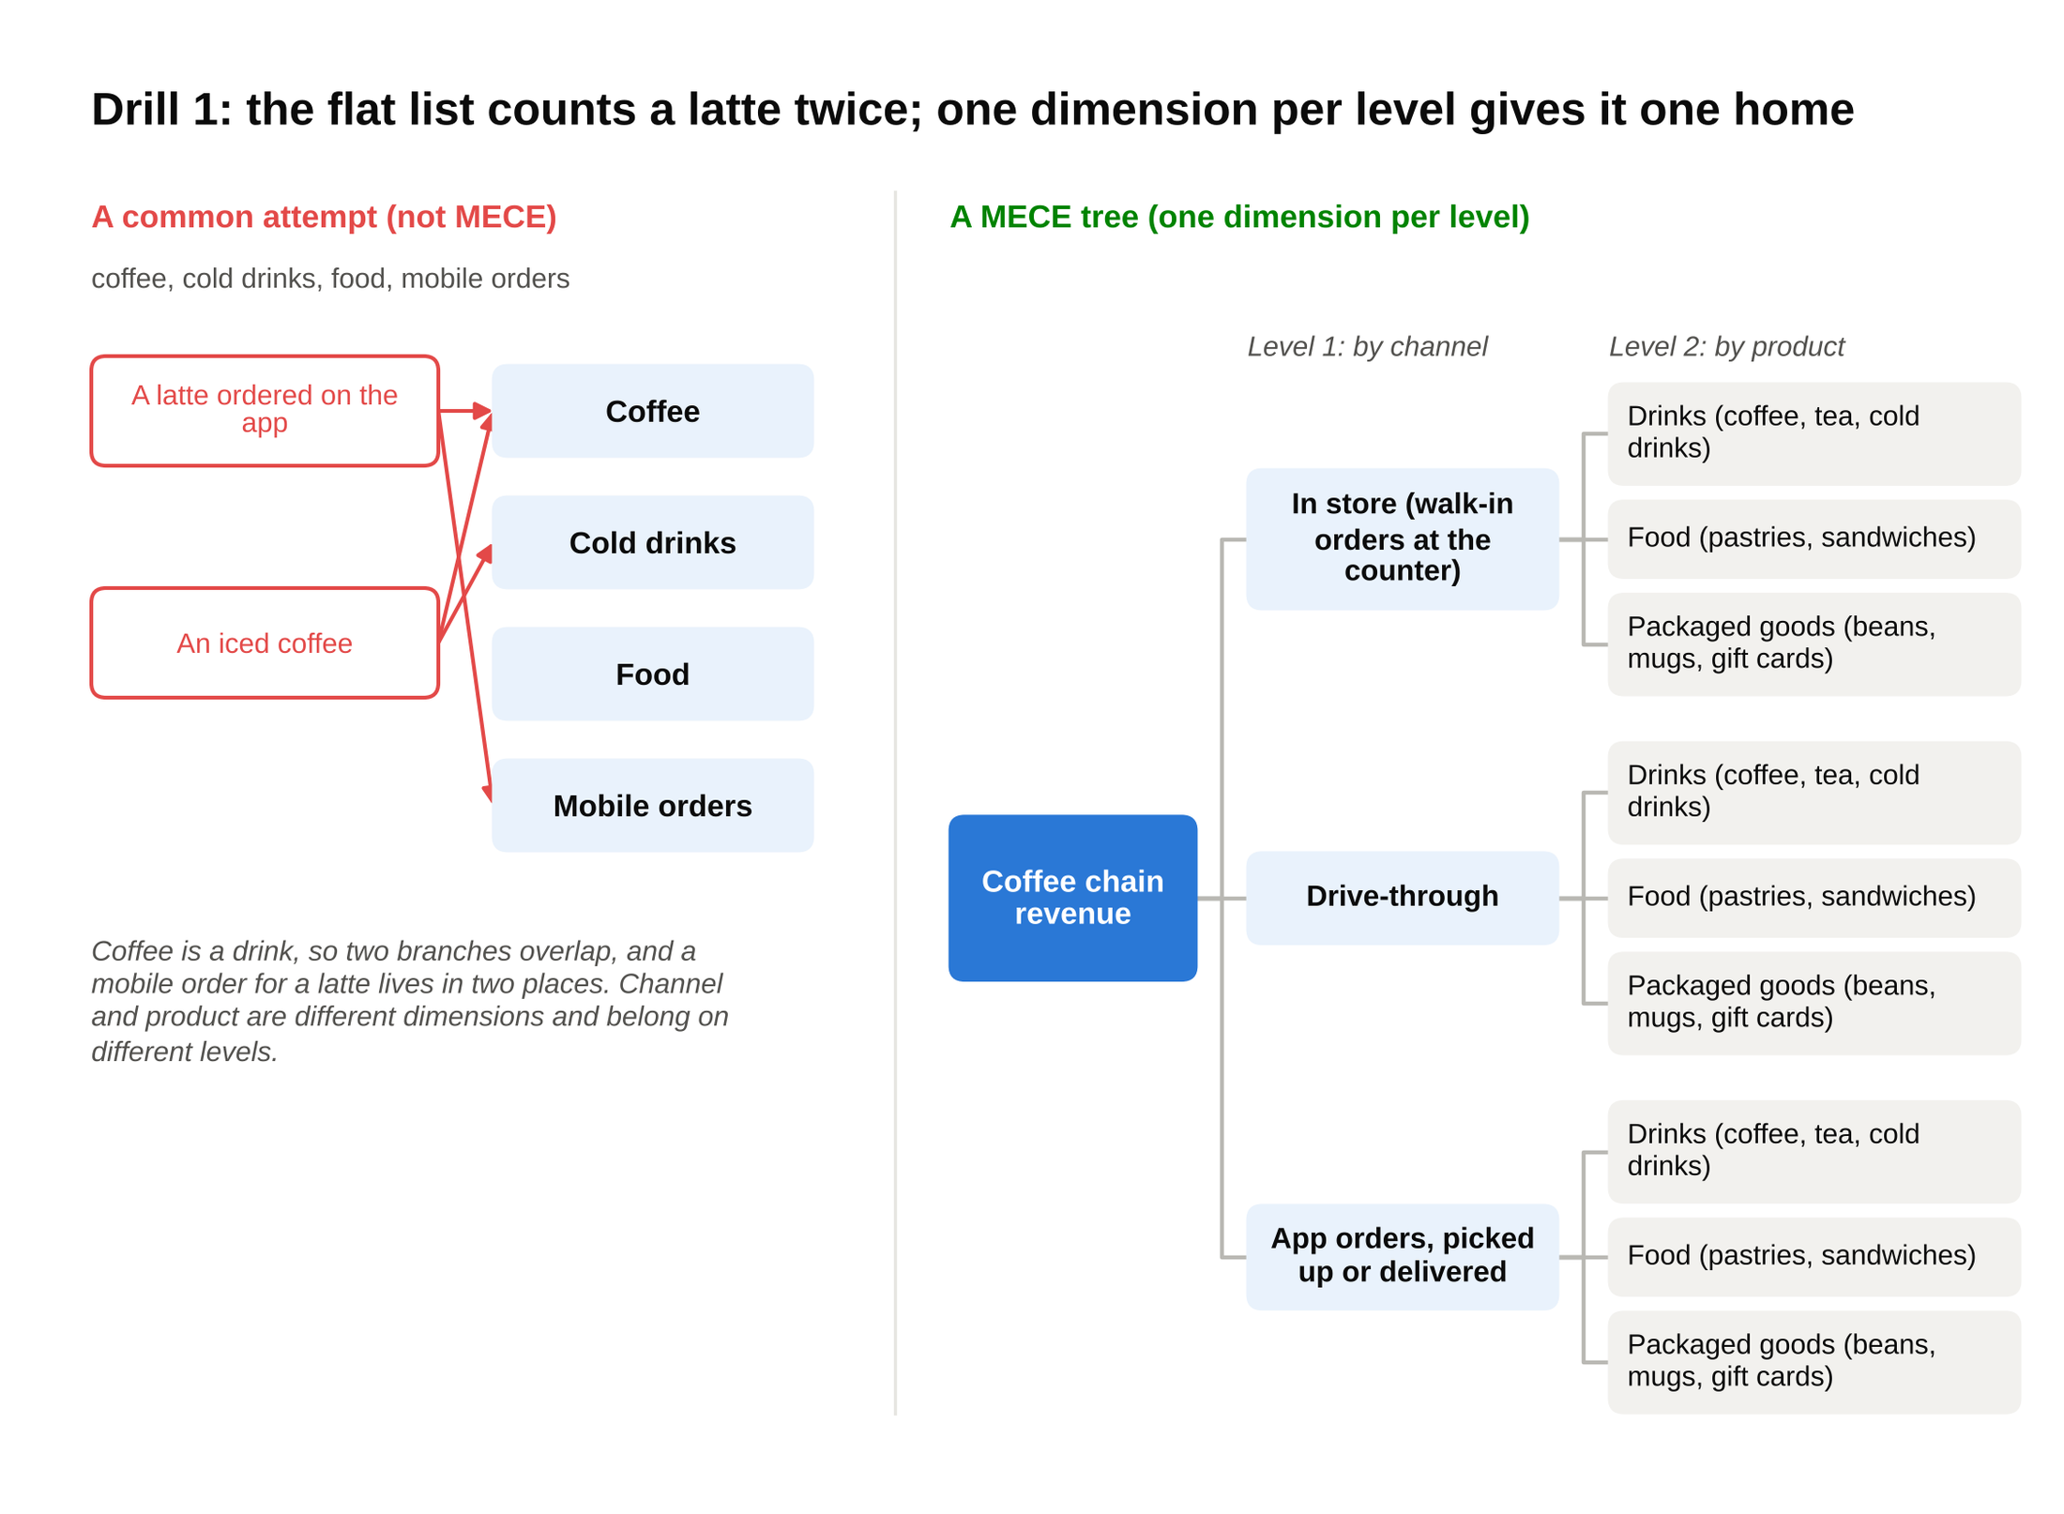
Drop a real order into each structure: the flat list gives a latte ordered on the app two homes, and the tree with channel above product gives it one.

Drill 2: Why are a hospital's emergency room wait times up?

A MECE tree (cut by the formula behind any waiting line: a wait grows when more people arrive, fewer are served at once, each one takes longer, or the exits are blocked):

- Wait time rose
- More patients arriving (demand)
- More arrivals overall
- The same arrivals bunched into the same hours
- Fewer staffed spots to see them (capacity)
- Fewer doctors and nurses per shift
- Beds closed
- Each patient taking longer in the room (process)
- A sicker mix, so each patient needs more time
- Slow check-in and triage (the first quick assessment that ranks patients by urgency)
- Slow test results (imaging, bloodwork)
- Patients who can't leave the ER (outflow)
- Admitted patients waiting for a bed upstairs, blocking an ER bed

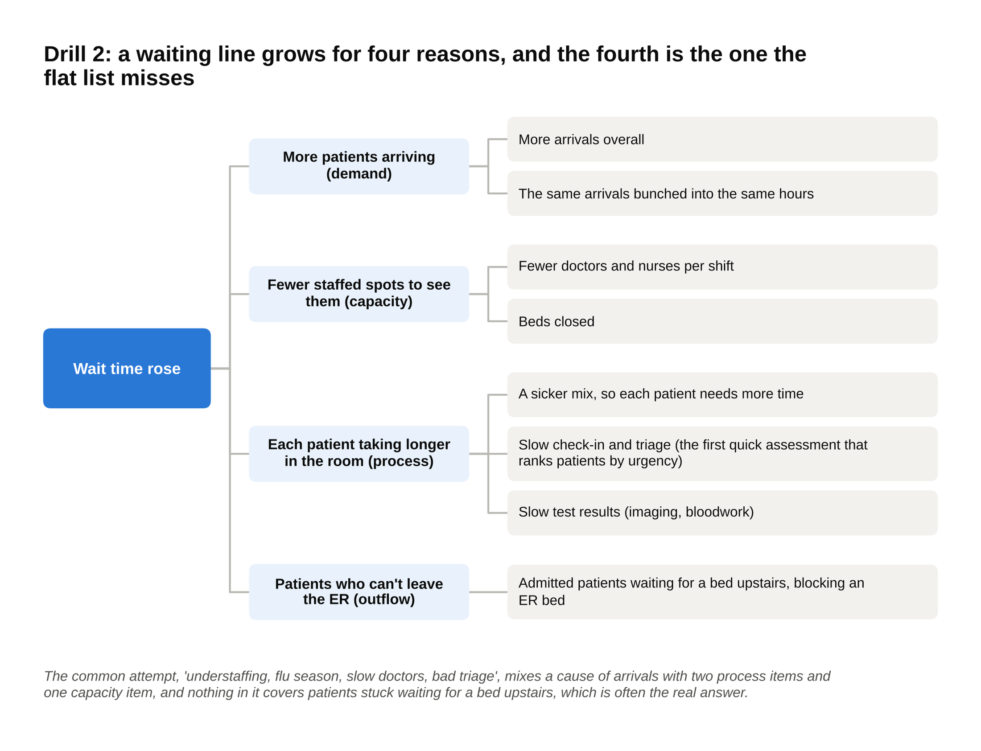
The formula behind any queue gives four branches, and the outflow branch (patients admitted but stuck in the ER) is the one a list of complaints leaves out.

A common non-MECE attempt: "understaffing, flu season, slow doctors, bad triage." Flu season is a cause of arrivals, slow doctors and bad triage are both process, understaffing is capacity, and nothing covers patients stuck waiting for a bed upstairs, which is often the real answer.

Drill 3: What are the costs of a gym?

A MECE tree (cut by opposites, then by line):

- Gym costs
- Fixed: the same whether 1,000 or 5,000 people show up
- Rent
- Equipment leases and replacement
- Salaried staff (manager, front desk)
- Insurance and software
- Variable: rises with members and visits
- Hourly staff and class instructors
- Utilities, towels, cleaning, supplies
- Card processing fees on each payment

Quick numbers: 5,000 members × $40 a month × 12 = $2.4 million of revenue. Fixed costs of $1.5 million, variable costs of $90 per member per year, 5,000 × $90 = $450,000. Profit: $2.4 million minus $1.5 million minus $0.45 million = $450,000.

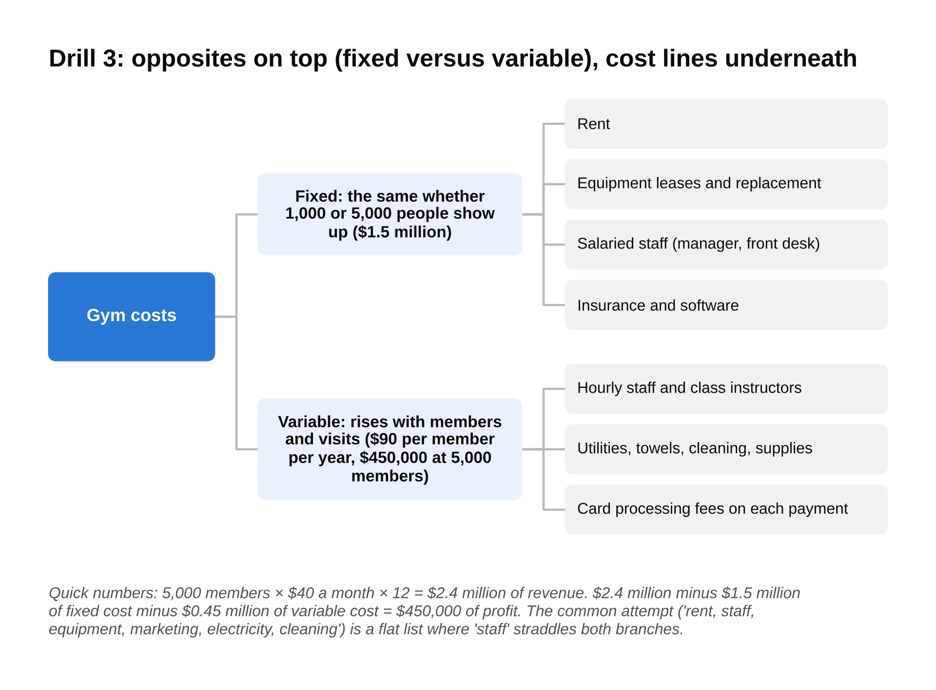
Fixed versus variable is a real pair of opposites, so every cost line has one branch, and 'staff' in the flat list fails because it sits in both.

A common non-MECE attempt: "rent, staff, equipment, marketing, electricity, cleaning." It's a flat list, "staff" straddles fixed and variable, and insurance and card fees are missing.

Drill 4: How could a regional bank grow deposits?

A MECE tree (cut by formula, then by segment):

- Deposits = number of accounts × average balance per account
- More accounts
- Keep more of the accounts it has (fewer closures)
- Open more new accounts
- By customer: consumers, small businesses
- By channel: branches, online
- Higher balance per account
- Rates paid on savings
- Features that pull in a customer's main paycheck (direct deposit, bill pay)

Quick numbers: 200,000 accounts × $12,000 average = $2.4 billion. Adding 10,000 accounts at the average adds $120 million; raising the average balance by $600 across all accounts adds $120 million too. Same prize, different work.

A common non-MECE attempt: "advertising, better rates, more branches, a better app." Those are levers, not drivers, and they overlap (advertising and branches both open accounts). Put the formula on top and hang the levers under the driver each one moves.

Drill 5: Why did a streaming service lose subscribers?

A MECE tree (cut by formula):

- Subscribers at year end = subscribers at the start + new sign-ups minus cancellations
- Fewer new sign-ups
- People new to streaming
- People switching from a rival
- People coming back after cancelling before
- More cancellations
- Chosen: the customer cancelled (price, content, a rival's show)
- Not chosen: the card failed or the account was shared and got cut off

A common non-MECE attempt: "price increase, weak content, competition, password-sharing crackdown." All four might be true, and they're a list, not a tree. The price increase affects both sign-ups and cancellations, so it belongs under both branches as a cause, not as a branch of its own.

Drill 6: How many electric bikes are sold in the US each year?

A MECE tree (a sizing cut by buyer type, then the formula for each):

- E-bikes sold per year = people who want one × share who buy this year
- Commuters replacing some car or transit trips
- Recreational riders
- Delivery and commercial riders
- For each: people in the segment × share who'd own an e-bike × (new buyers this year + owners replacing an old one)

A rough pass for the drill, not the real figure: about 260 million US adults, say 10 percent ride a bike regularly (26 million), 15 percent of those would own an e-bike (3.9 million owners). If a bike lasts six years, replacements alone are about 650,000 a year, and growth on top takes the estimate toward a million. Sanity check the shares out loud; the structure matters more than the number.

A common non-MECE attempt: "bike shop sales, Amazon sales, online sales." Amazon is online, so two branches overlap, and the split says nothing about who's buying or why.

Drill 7: Should a grocery chain add self-checkout?

A MECE tree (a decision cut: benefits, costs, risks):

- Add self-checkout in 100 stores?
- What it gains
- Labor saved: about 3 cashier positions per store × $35,000 = $105,000 a year
- Shorter lines at peak hours (hard to value, real for customers)
- What it costs
- Equipment: 6 machines × $30,000 = $180,000 per store, one time
- Maintenance and software: about $15,000 a year per store
- Theft and scanning errors ("shrink"): about 0.3 percent of a store's $20 million in sales = $60,000 a year
- What could go wrong
- Customers who hate it and shop elsewhere
- Staff and union reaction

Net per store: $105,000 minus $15,000 minus $60,000 = $30,000 a year, against $180,000 of equipment. Payback: six years. The shrink line is what most candidates forget, and it turns a great-looking idea into a marginal one.

A common non-MECE attempt: a pros-and-cons list where "saves money" and "fewer cashiers" sit as two separate pros. Same thing, counted twice.

Drill 8: Where does a hotel housekeeper's time go?

A MECE tree (cut by process, one room at a time):

- Minutes per room (standard: 30)
- Getting to the room: walking, cart restocking between rooms
- Stripping: removing linens and trash
- Bathroom: cleaning and restocking
- Bedroom: making the bed, dusting, vacuuming
- Restocking: towels, amenities, minibar
- Inspection and logging the room as ready

A common non-MECE attempt: "cleaning, inspections, breaks, slow staff." Breaks aren't part of a room, "slow staff" is a cause rather than a step, and "cleaning" is four of the six steps lumped together, which hides where the extra minutes are.

Drill 9: Why did a university's applications fall?

A MECE tree (cut by the applicant's path, then internal versus external at each step):

- Applications submitted = prospects who hear of the school × share who inquire × share who start an application × share who finish it
- Fewer prospects hearing of the school (demographics, outreach, rankings)
- Fewer inquiring (website, campus visits, counselor relationships)
- Fewer starting the application (fees, essay load, test requirements)
- Fewer finishing it (deadline, portal, follow-up)
- At each step: did the school change something, or did the world (competitors, the economy, policy)?

A common non-MECE attempt: "tuition, rankings, demographics, marketing, the website." A flat list of five causes with no steps. Tuition and rankings can hit every step, the website hits one, and nothing tells the interviewer where in the funnel the drop appeared.

Drill 10: How can a trucking company cut its fuel bill?

A MECE tree (cut by formula, then by cause):

- Fuel cost = gallons × price per gallon
- Gallons = miles driven ÷ miles per gallon
- Miles driven
- Loaded miles (paid)
- Empty miles (driving to the next load, unpaid)
- Miles per gallon
- The truck: engine spec, tires, maintenance, aerodynamics
- The driver: speed, idling, braking
- Price per gallon
- Where and when the fleet fills up, bulk contracts, fuel hedging

Quick numbers: 10 million miles ÷ 6.5 miles per gallon = about 1.54 million gallons × $3.80 = about $5.85 million. If empty miles fall from 15 percent of total miles to 10 percent with the same loaded miles, total miles fall to about 9.44 million, gallons to about 1.45 million, and the bill to about $5.52 million, a saving of roughly $320,000. Raising miles per gallon from 6.5 to 7.0 on those miles saves another $390,000 or so.

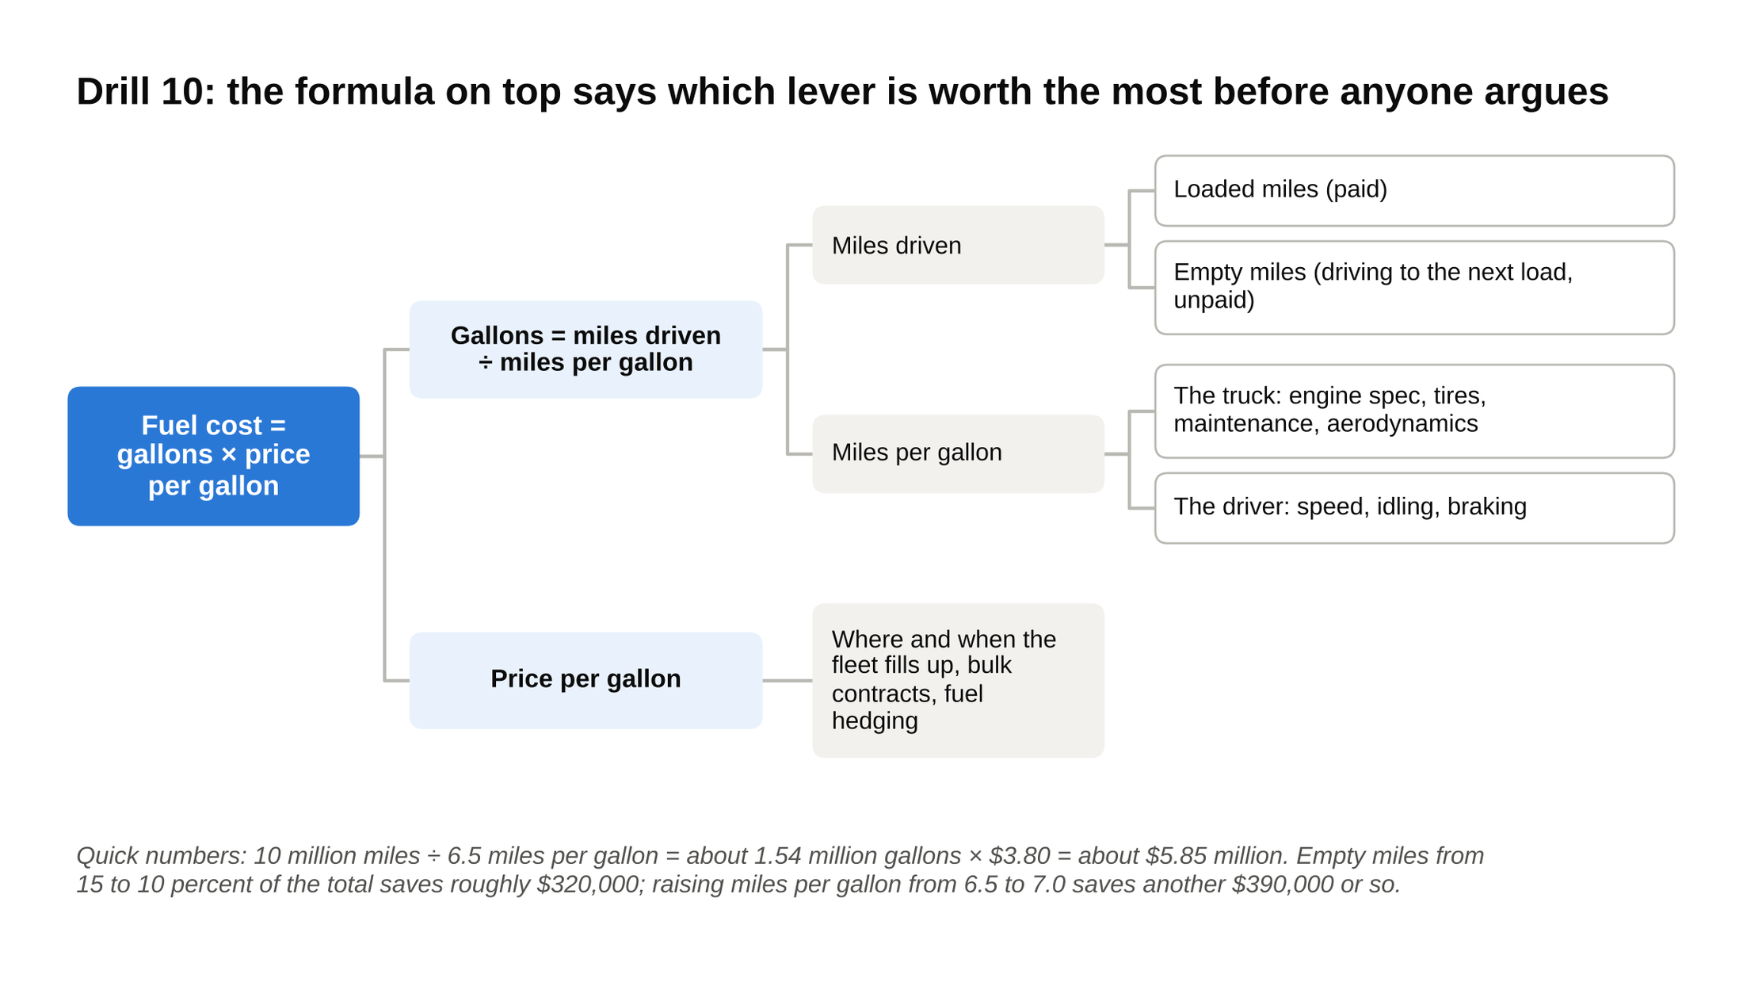
Driver training and newer trucks both move miles per gallon, better routes move miles driven and fuel cards move price, and the formula on top is what lets you size them against each other.

A common non-MECE attempt: "driver training, better routes, newer trucks, fuel cards." Four levers with no formula above them. Driver training and newer trucks both move miles per gallon, better routes moves miles driven, fuel cards move price, and the candidate can't say which lever is worth the most until the formula is on the board.

In every drill the failed attempt is a flat list of levers or causes, and the fix is the same each time: put the formula or the flow on top and hang the causes underneath it.

Say this, don't say that when you present a structure
Opening the structure

Don't say: "I'll use the profitability framework."

Say: "Profit is revenue minus cost, so I'd split this into the two and find which one moved. On revenue I'd look at price and volume separately. On cost I'd take the chain's four big lines: food, labor, occupancy, and everything else."

When you spot an overlap in your own tree

Don't say: nothing, and hope the interviewer didn't notice.

Say: "Actually, overtime sits inside labor, so let me fold it in. The three cost branches are labor, materials, and occupancy."

When the interviewer asks, "is that everything?"

Don't say: "I think so."

Say: "Those four cover every cost line a restaurant has. If anything doesn't fit, it lands in 'everything else,' and I'd name what's in it: marketing, supplies, head office."

Closing the structure

Don't say: "It could be any of these, so I'd look at all of them."

Say: "I'd start with labor, because it's the largest line and the prompt mentioned a wage increase. If labor explains most of the drop, the fix is scheduling. If it doesn't, I'd move to food cost."

Synthesizing at the end

Don't say: "There are a lot of factors here."

Say: "Three reasons, no overlap. Costs are up $11.2 million, mostly labor. Revenue is down $2.7 million, because lost covers outweighed the price increase. The lever the client controls is hours per cover, and fixing it recovers about $4.6 million."

Where to start this week
Pick ten prompts, any ten, from a case book or the drills above. For each one, set a 90-second timer and build only the tree: three to five branches, one cut per level. When the timer goes, run the overlap test with three real items, the gap test with one invented one, and say the hypothesis out loud. Then redraw once, merging anything that turned out to be the same kind of thing.

Ten trees in 90 seconds each, with both tests run out loud, is a week of practice that changes how you open a case. Do it and the acronym stops being a word you know and becomes a thing you can do. That's the gap my engagement manager closed with one marker line, and it's the gap your interviewer is checking for in the first two minutes.

